Mobile Storage Analytics

Software Requirements Specifications

Team CodeStars

Project Members

• Hisham Alhussain • Matthew LeBlanc

• Joy Liu • Yueying Liu

• Paul Maurais • Aisiri Murulidhar

• Siddharth Naidu • Varun Sharma

• Andrew Sharp • Quyen Tran

• Cody Dyl (manager)

Table of Contents

1. [**Introduction**](#_tr0th0argymd) **3**

1.1 [Purpose of System](#_3btoozf46l2v) 3

1.2 [Context](#_x7zwbukotc04) 3

1.3 [Stakeholders](#_531d53pjs9xp) 3

2. [**Overall System Description**](#_qy0o287rmink) **4**

2.1 [Type of Product](#_6vy7mbekb8an) 4

2.2 [Functionality](#_8uz9kkolit8j) 4

2.3 [Types of Users](#_3emaf8ldfjhh) 4

3. [**Functional Requirements**](#_pnjbk1lcrsgr) **5**

3.1 [Main Functions](#_sjzba5shl0z4) 5

3.2 [Use Cases](#_7frxgj3iu7zm) 6

3.2.1 [Use Case 1: Login](#_3i9olm432imm) 6

3.2.2 [Use Case 2: User receives aggregated info](#_pehl2kx4lnlt) 6

3.2.3 [Use Case 3: User performs search](#_ukphneklwjmp) 7

3.2.4 [Use Case 4: User selects filter](#_gwmr6nt77fgs) 7

3.2.5 [Use Case 5: Show data graph](#_wmpefwuqsuh6) 8

3.2.6 [Use Case 6: Display disk info](#_8twpoo7lbsfi) 8

3.2.7 [Use Case 7: Send disk health alerts](#_ti28fjxqzw9h) 9

4. [**Non-Functional Requirements**](#_vroetwqr00o4) **10**

4.1 [Design/Implementation](#_67lyapqq14pv) 10

4.2 [Performance/Usability](#_rv8f4ekuelvo) 10

5. [**Future Requirements**](#_yotp9jf76bx1) **11**

5.1 [Real Time Updates](#_r6imfmuflfqs) 11

5.2 [Authentication](#_hqswufbd6ptr) 11

5.3 [Export Dashboard View as PDF](#_kjskwfig8sch) 11

5.4 [Capacity Trend Prediction](#_bs3bfhs4fuu0) 11

6. [**UI Sketches**](#_kiw1rofa27gq) **12**

6.1 [Use Case 1: Login](#_hztf8o7h6cq1) 12

6.2 [Use Case 2: User receives aggregated info](#_la7ccl8wehy0) 13

6.3 [Use Case 3: User performs search](#_k17nfeifuf5s) 14

6.4 [Use Case 4: User selects filter](#_hv7z3p20jfay) 14

6.5 [Use Case 5: Show data graph](#_o1m1cw3fk075) 15

6.6 [Use Case 6: Display disk info](#_oyebvhev1lyp) 16

6.7 [Use Case 7: Send disk health alerts](#_1b0dmbe5midq) 16

7. [**Glossary of Terms**](#_bjr3vscbr4t4) **17**

# 1. Introduction

## 1.1 Purpose of System

The purpose of this system is to provide a mobile based application that displays storage analytics for a series of storage units. The application generates graphical and visual representations of the data depending on how the user chooses to view it. The application periodically has its data updated to ensure data accuracy and reliability.

## 1.2 Context

The current system uses a website to access the big data analytics information for users. Information provided to the user includes detailed information, historical trends, prediction and alerting, and real-time analytics. The new system is a mobile application version of the website.

The application will provide configuration data for individual systems and aggregate information across multiple systems within HP. The application should function very similarly to the current website but with the convenience of being on a mobile platform. The Users of HP’s analytics services will benefit from having an alternative way of accessing their data on the go. The Sales and Support employees within HP will benefit from having an alternative way of monitoring their analytics services and helping Users that are having problems. The Administration within HP monitoring the analytics services will benefit from having a portable way of maintaining the services.

## 1.3 Stakeholders

1. HP
   * HP will benefit from having a mobile version of their data analytics website. It is another product that they can provide to the consumers and employees.
2. Developers
   * The developers benefit from the creation of the application by gaining experience in software development.
3. Sales and Support
   * The Sales and Support employees within HP have an alternative way of monitoring their analytics services and troubleshoot problems for Users.
4. Users
   * Users of HP’s analytics services will benefit from another solution to monitor their data. It could prove convenient for those always on the go and need a quick and easy way to check their analytics suited for their phones.
5. Administrators
   * Administration at HP will benefit from portable troubleshooting of problems on their mobile device.

# 2. Overall System Description

## 2.1 Type of Product

This app is a subsystem of the existing Hewlett Packard Enterprise storage and analytics system. Data from users’ storage systems is currently available through an HP website. This product will receive data from the HP servers and make that data viewable in a mobile format for the user's convenience.

## 2.2 Functionality

App will allow users to:

1. View data for an individual system
2. View data aggregated across all of their systems
3. Search for systems that fit specific criteria
4. Filter displayed systems by specific criteria
5. Receive alerts when the data indicates a problem with one of the user’s systems

## 2.3 Types of Users

|  |  |
| --- | --- |
| **User Category** | **Description** |
| Customer | Able to see individual and aggregated data for their systems |
| Employee | Includes administrators, sales, and support staff; able to see trends in aggregated data |

# AF3. Functional Requirements

## 3.1 Main Functions

**3.1.1 Login functionality -** The login functionality allows for individual accounts for all clients of the product and ensures privacy and encapsulation of each individual’s profiles and information. For security, users are prompted to create a unique password in order to access their account as well as an account identification number. For additional protection, users are also asked to provide specific answers to security questions in case of fraud.

**3.1.2 Aggregated info for individual users -** Individual clients of the product will have convenient access to details across all owned storage spaces in the service. Clients have the ability to access specific information by including their search specifications into the aggregated information function. HP employees will have universal access to storage space information across all users and can access any specific information at will.

**3.1.3 Search functionality -** Users will be able to search for systems that fit specific criteria such as a specific storage capacity. The app will then display a list of systems fitting the desired criteria.

**3.1.4 Filter functionality -** When viewing data aggregated across systems, users will be able to filter by specific criteria to view data trends across only the systems fitting the desired criteria. For example, they can view trends in storage usage across systems of only one specific type of storage device.

**3.1.5 Data visualization -**  Our data visualization will generate state of the art GUI representing the aggregated information specified by the clients. Visualization provides a comprehensive high level understanding for both the client and provider on the status and details on each data storage unit.

**3.1.6 Generate a list of physical disks that the logged in user can see** - Generates a list of physical disks that users can view. Users will be able to choose a specific physical disk and view a series of attributes associated with that disk. The attributes include manufacturer, model, free capacity, capability, etc.

**3.1.7 Send alerts -** The alert functionality will alert customers when their drives are almost full or other such performance hindrances. Clients will be alerted about their own devices while HP employees will be able to view the alerts that are sent to any system to be able to diagnose issues or use it to aid in knowing appropriate products to offer to sell to customers.

## 3.2 Use Cases

|  |  |
| --- | --- |
| 3.2.1 Use Case 1: Login |  |
| **Trigger:** | Actor taps on “Login” button |
| **Actor:** | All user types |
| **Precondition:** | 1. Actor has an account |
| **Main success scenario/Steps:** | 1. System prompts actor to enter their credentials 2. Actor enters their username/password 3. The system validates the entered credentials and displays a login message |
| **Successful post-condition:** | Actor is logged in and brought to the dashboard view |
| **Exception conditions:** | 1. Username and/or password incorrect    1. Actor is returned to login page with both fields (username/password) cleared out |

|  |  |
| --- | --- |
| 3.2.2 Use Case 2: User goes to storage list view |  |
| **Trigger:** | Actor taps on “Storage List” button |
| **Actor:** | All user types |
| **Precondition:** | 1. Actor is logged in 2. Actor is on the dashboard view |
| **Main success scenario/Steps:** | 1. System collects list of actor’s disks |
| **Successful post-condition:** | System displays storage list view |
| **Exception conditions:** | 1. Could not connect to database    1. “Please check connection” message is displayed |

|  |  |
| --- | --- |
| 3.2.3 Use Case 3: User performs search |  |
| **Trigger:** | Actor taps “Search” button |
| **Actor:** | All user types |
| **Preconditions:** | 1. Actor is logged in |
| **Main success scenario/Steps:** | 1. Actor types search query into search box and presses enter 2. System matches typed text with entries in database 3. System compiles a list based on relevant entries |
| **Alternate flow:** | 1. No matches found    1. “No matches found” message is displayed    2. Search bar is cleared    3. Go to step 1 |
| **Successful post-condition:** | System displays list of results |
| **Exception conditions:** | 1. Could not connect to database    1. “Please check connection” message is displayed |

|  |  |
| --- | --- |
| 3.2.4 Use Case 4: User selects filter |  |
| **Trigger:** | Actor selects “Filter” from menu |
| **Actor:** | All user types |
| **Preconditions:** | 1. Actor is logged in |
| **Main success scenario/Steps:** | 1. Actor selects filter from list 2. System matches selected filter with entries in database 3. System compiles a list based on relevant entries |
| **Alternate flow:** | 1. No matches found    1. “No matches found” message is displayed    2. Filters are cleared    3. Go to step 1 |
| **Successful post-condition:** | System displays dashboard view |
| **Exception conditions:** | 1. Could not connect to database    1. “Please check connection” message is displayed |

|  |  |
| --- | --- |
| 3.2.5 Use Case 5: User goes to dashboard view |  |
| **Trigger:** | Actor taps on “Dashboard” button |
| **Actor:** | All user types |
| **Precondition:** | 1. Actor is logged in 2. Actor is in storage list view |
| **Main success scenario/Steps:** | 1. System generates graphs based on disk information |
| **Successful post-condition:** | System displays graphs on the screen |
| **Exception conditions:** | 1. Could not connect to database    1. “Please check connection” message is displayed |

|  |  |
| --- | --- |
| 3.2.6 Use Case 6: Display disk info |  |
| **Trigger:** | Actor taps on specific disk |
| **Actor:** | Customer |
| **Preconditions:** | 1. Actor must be logged in 2. Actor must own at least one disk 3. Actor is in storage list view |
| **Main success scenario/Steps:** | 1. System fetches info about selected disk from database 2. System compiles disk information |
| **Successful post-condition:** | System displays disk information |
| **Exception conditions:** | 1. Could not connect to database    1. “Please check connection” message is displayed |

|  |  |
| --- | --- |
| 3.2.7 Use Case 7: Send disk health alerts |  |
| **Trigger:** | System finds problem in a physical disk |
| **Actor:** | Customer |
| **Precondition:** | 1. Actor must be logged in 2. Actor must own at least one disk |
| **Main success scenario/Steps:** | 1. System checks on all physical disks’ health 2. System finds problem with a disk |
| **Alternate flow:** | 1. System does not find any problems with the disks    1. System schedules future check up |
| **Successful post-condition:** | System sends actor alert regarding disk problem |

# 4. Non-Functional Requirements

## 4.1 Design/Implementation

1. Conform to HP design standards
2. User friendly
3. Simple, clean interface
4. Clear, easy to view graphs and visuals associated with selected data

## 4.2 Performance/Usability

1. Easy navigation to view certain analytics
2. Fast response times
3. Security for users
   * Authenticated login system such that users can only view their own systems

# 

# 

# 5. Future Requirements

## 5.1 Real Time Updates

The app needs to dynamically update the information about systems based on real time updates from the database instead of relying on pre-uploaded data.

## 5.2 Authentication

The app needs to support a login/logout feature but does not need to lock features behind authenticated user accounts. The future requirement would be to implement an authentication system so that certain functions would only appear to the proper registered users.

## 5.3 Export Dashboard View as PDF

The app needs the ability to export the dashboard view as a PDF for an easy ability to share current statistics or keep records of the previous states of the system.

## 5.4 Capacity Trend Prediction

The app needs to predict when drives would approach max capacity based on historical data to be able to proactively alert users when they are approaching their maximum capacity.

# 

# 

# 6. UI Sketches

## 6.1 Use Case 1: Login

User enters credentials and system authenticates user. If the credentials are correct, the dashboard is displayed. If the credentials are incorrect, the user is navigated to a screen displaying an error message.

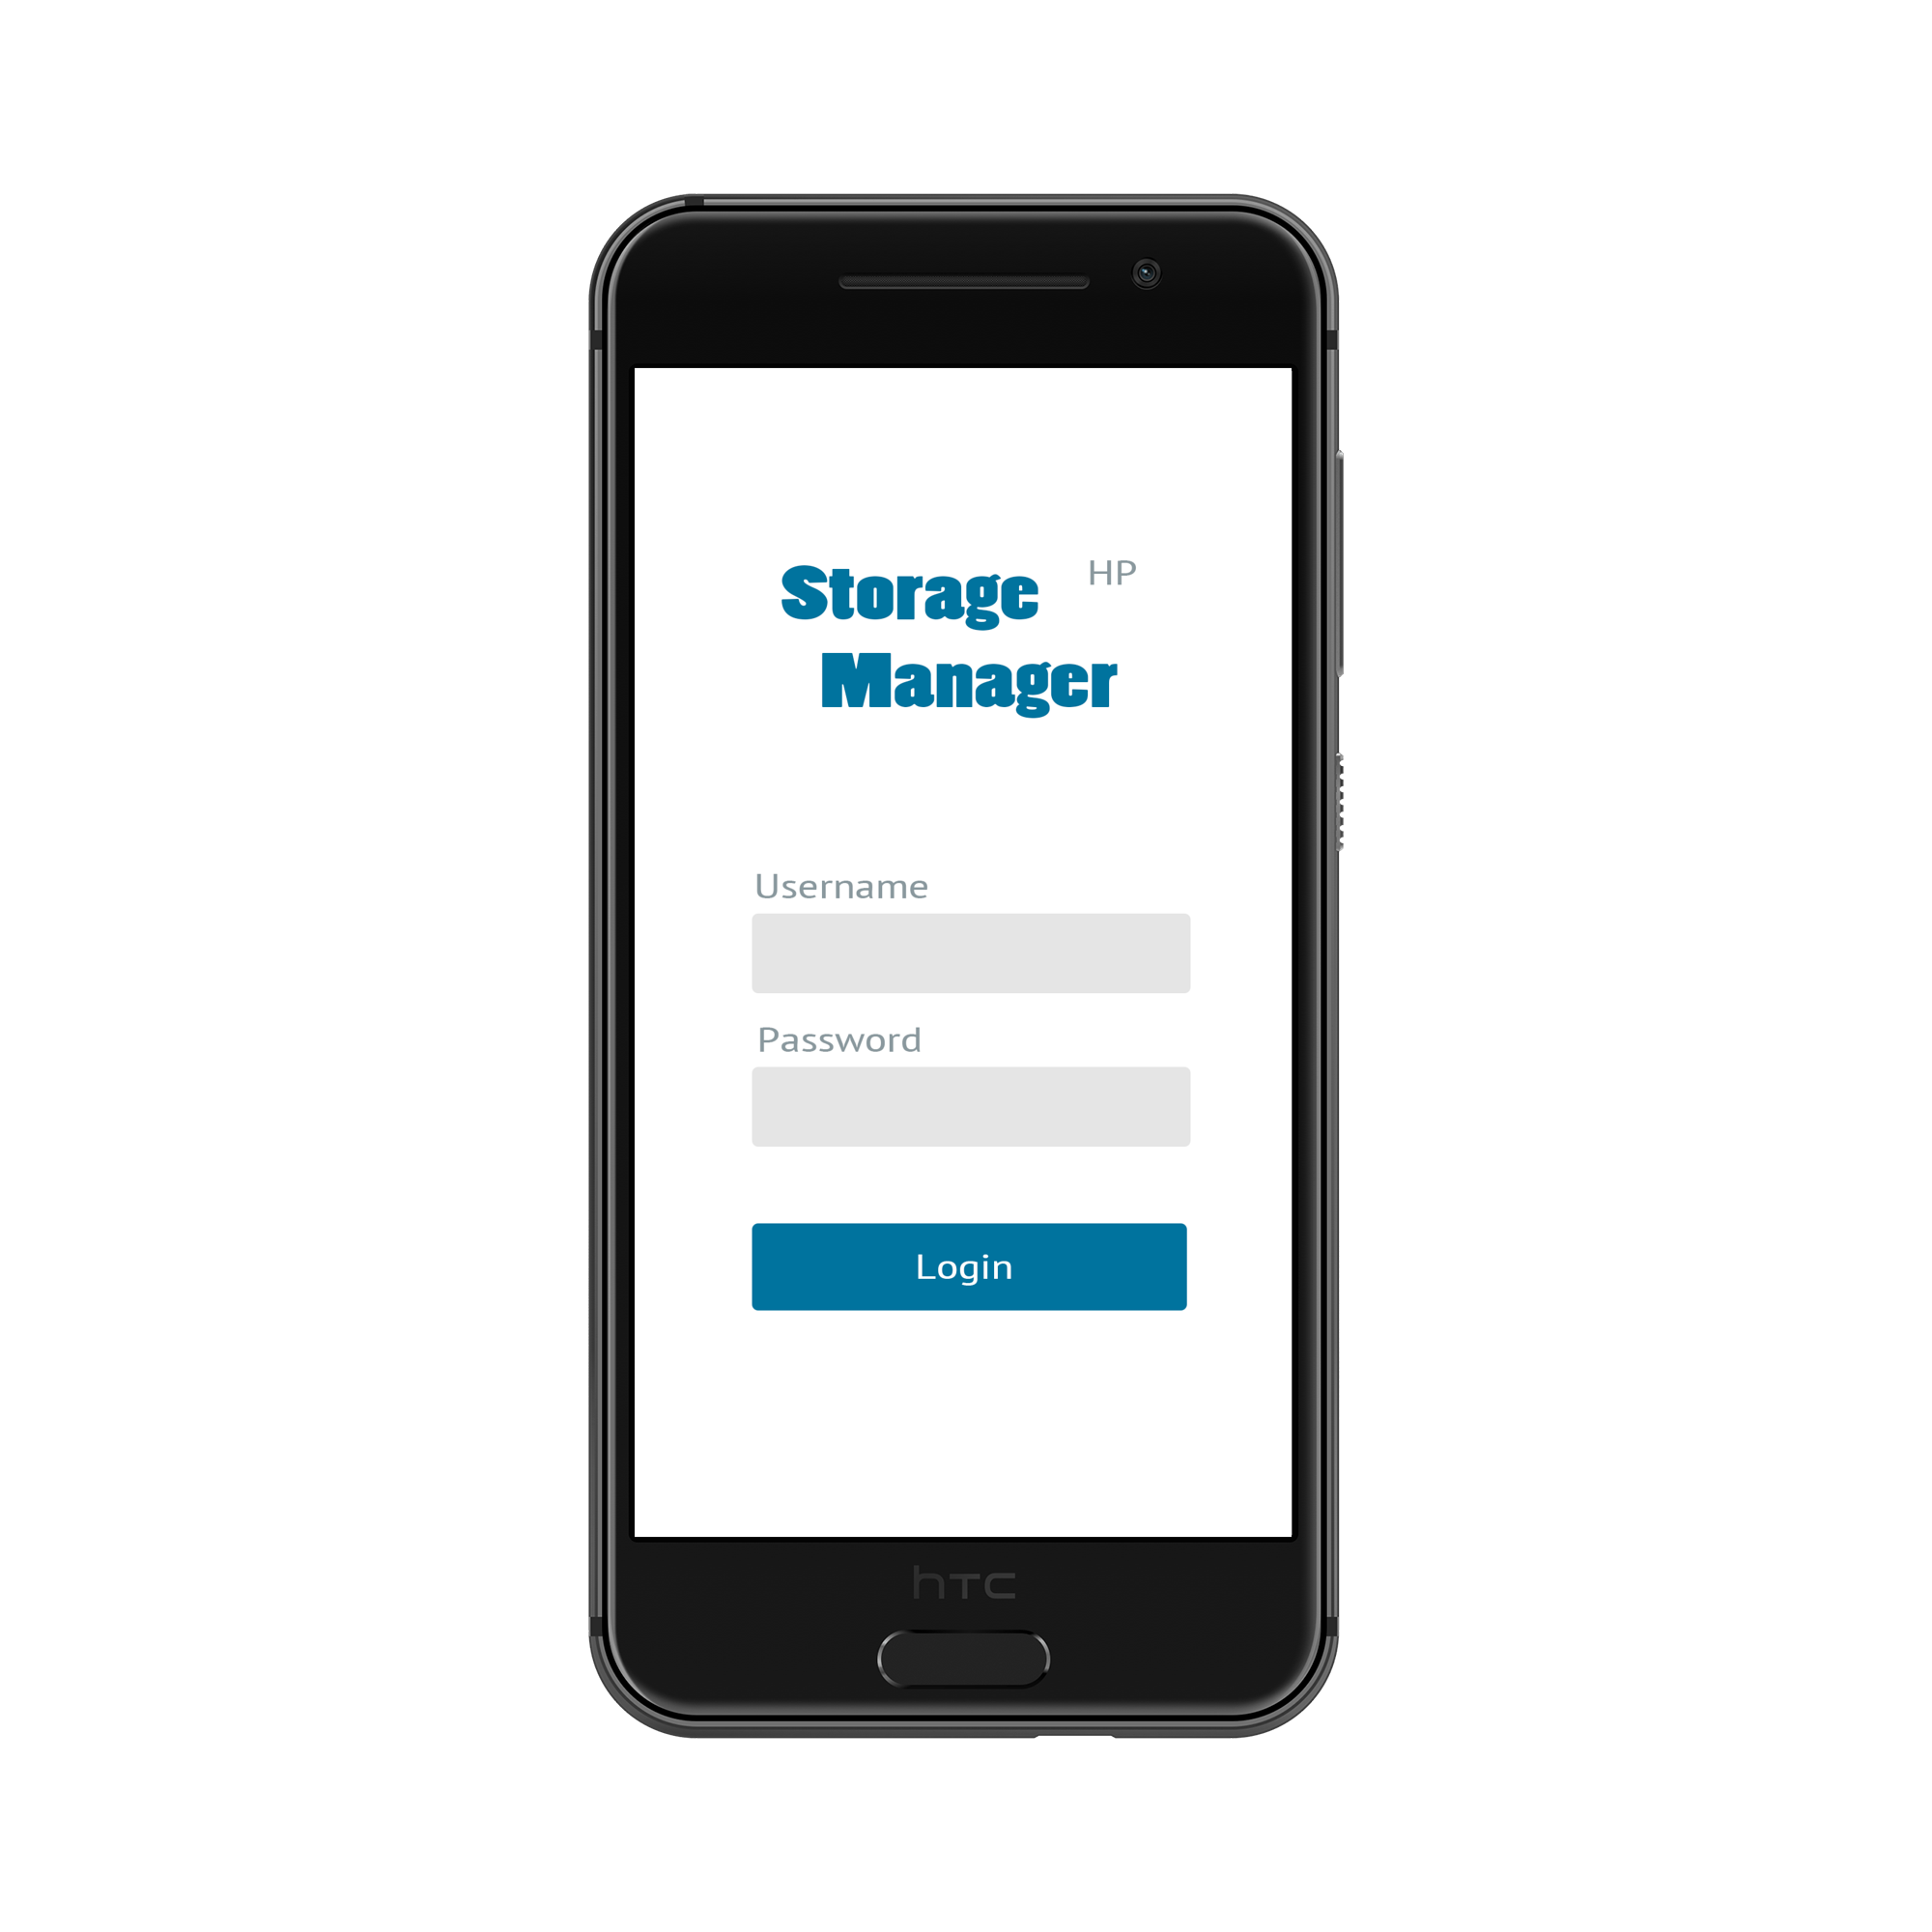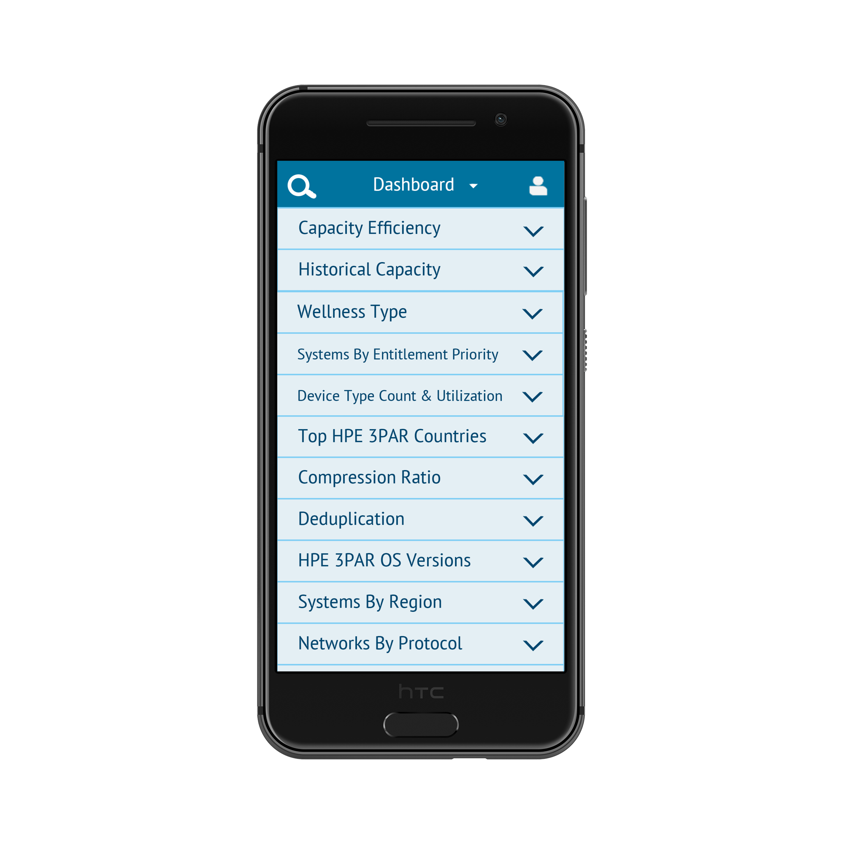





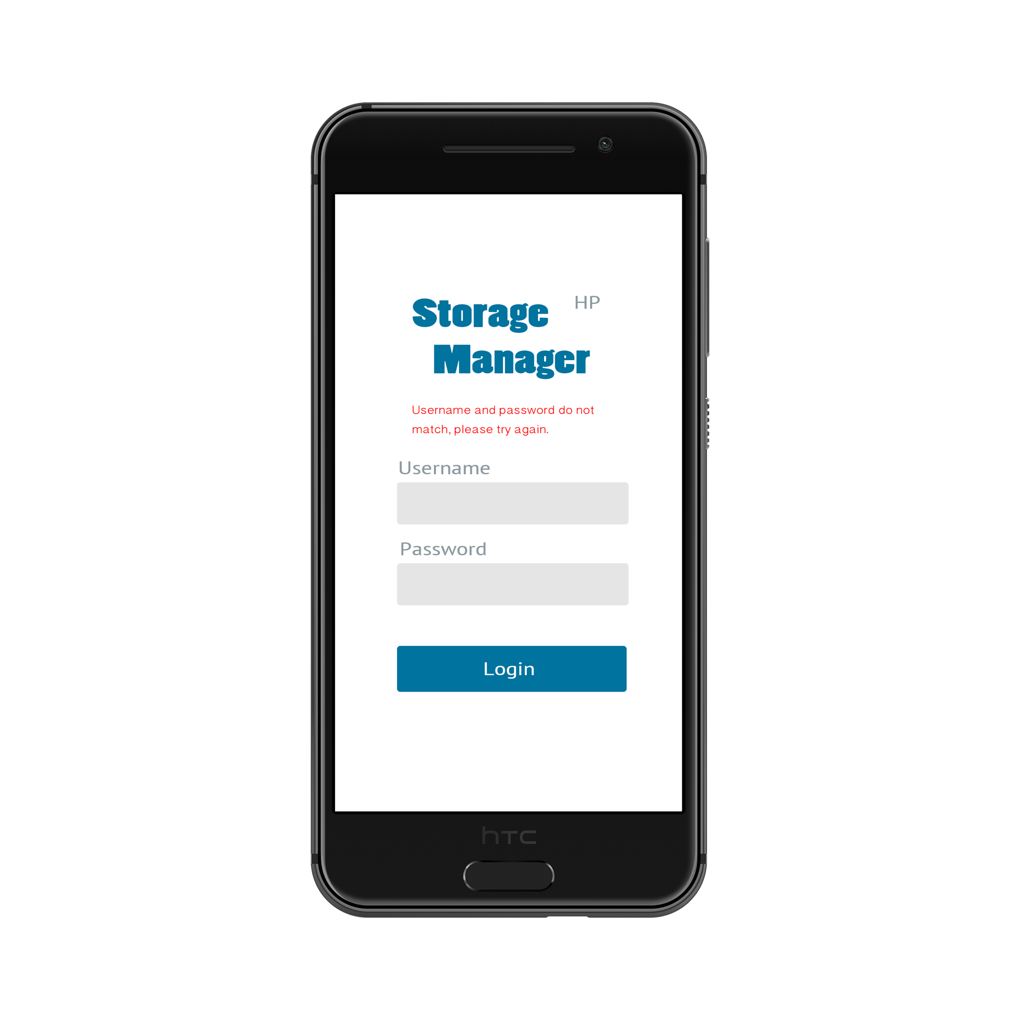

## 6.2 Use Case 2: User goes to storage list view

The dashboard is the default page after logging in. The users can change to the storage listview from the dashboard view through tapping the Storage List button. If the network connection is good, the unfiltered storage list is displayed. Otherwise, the error message pops up, and the storage list in the RAM appears.

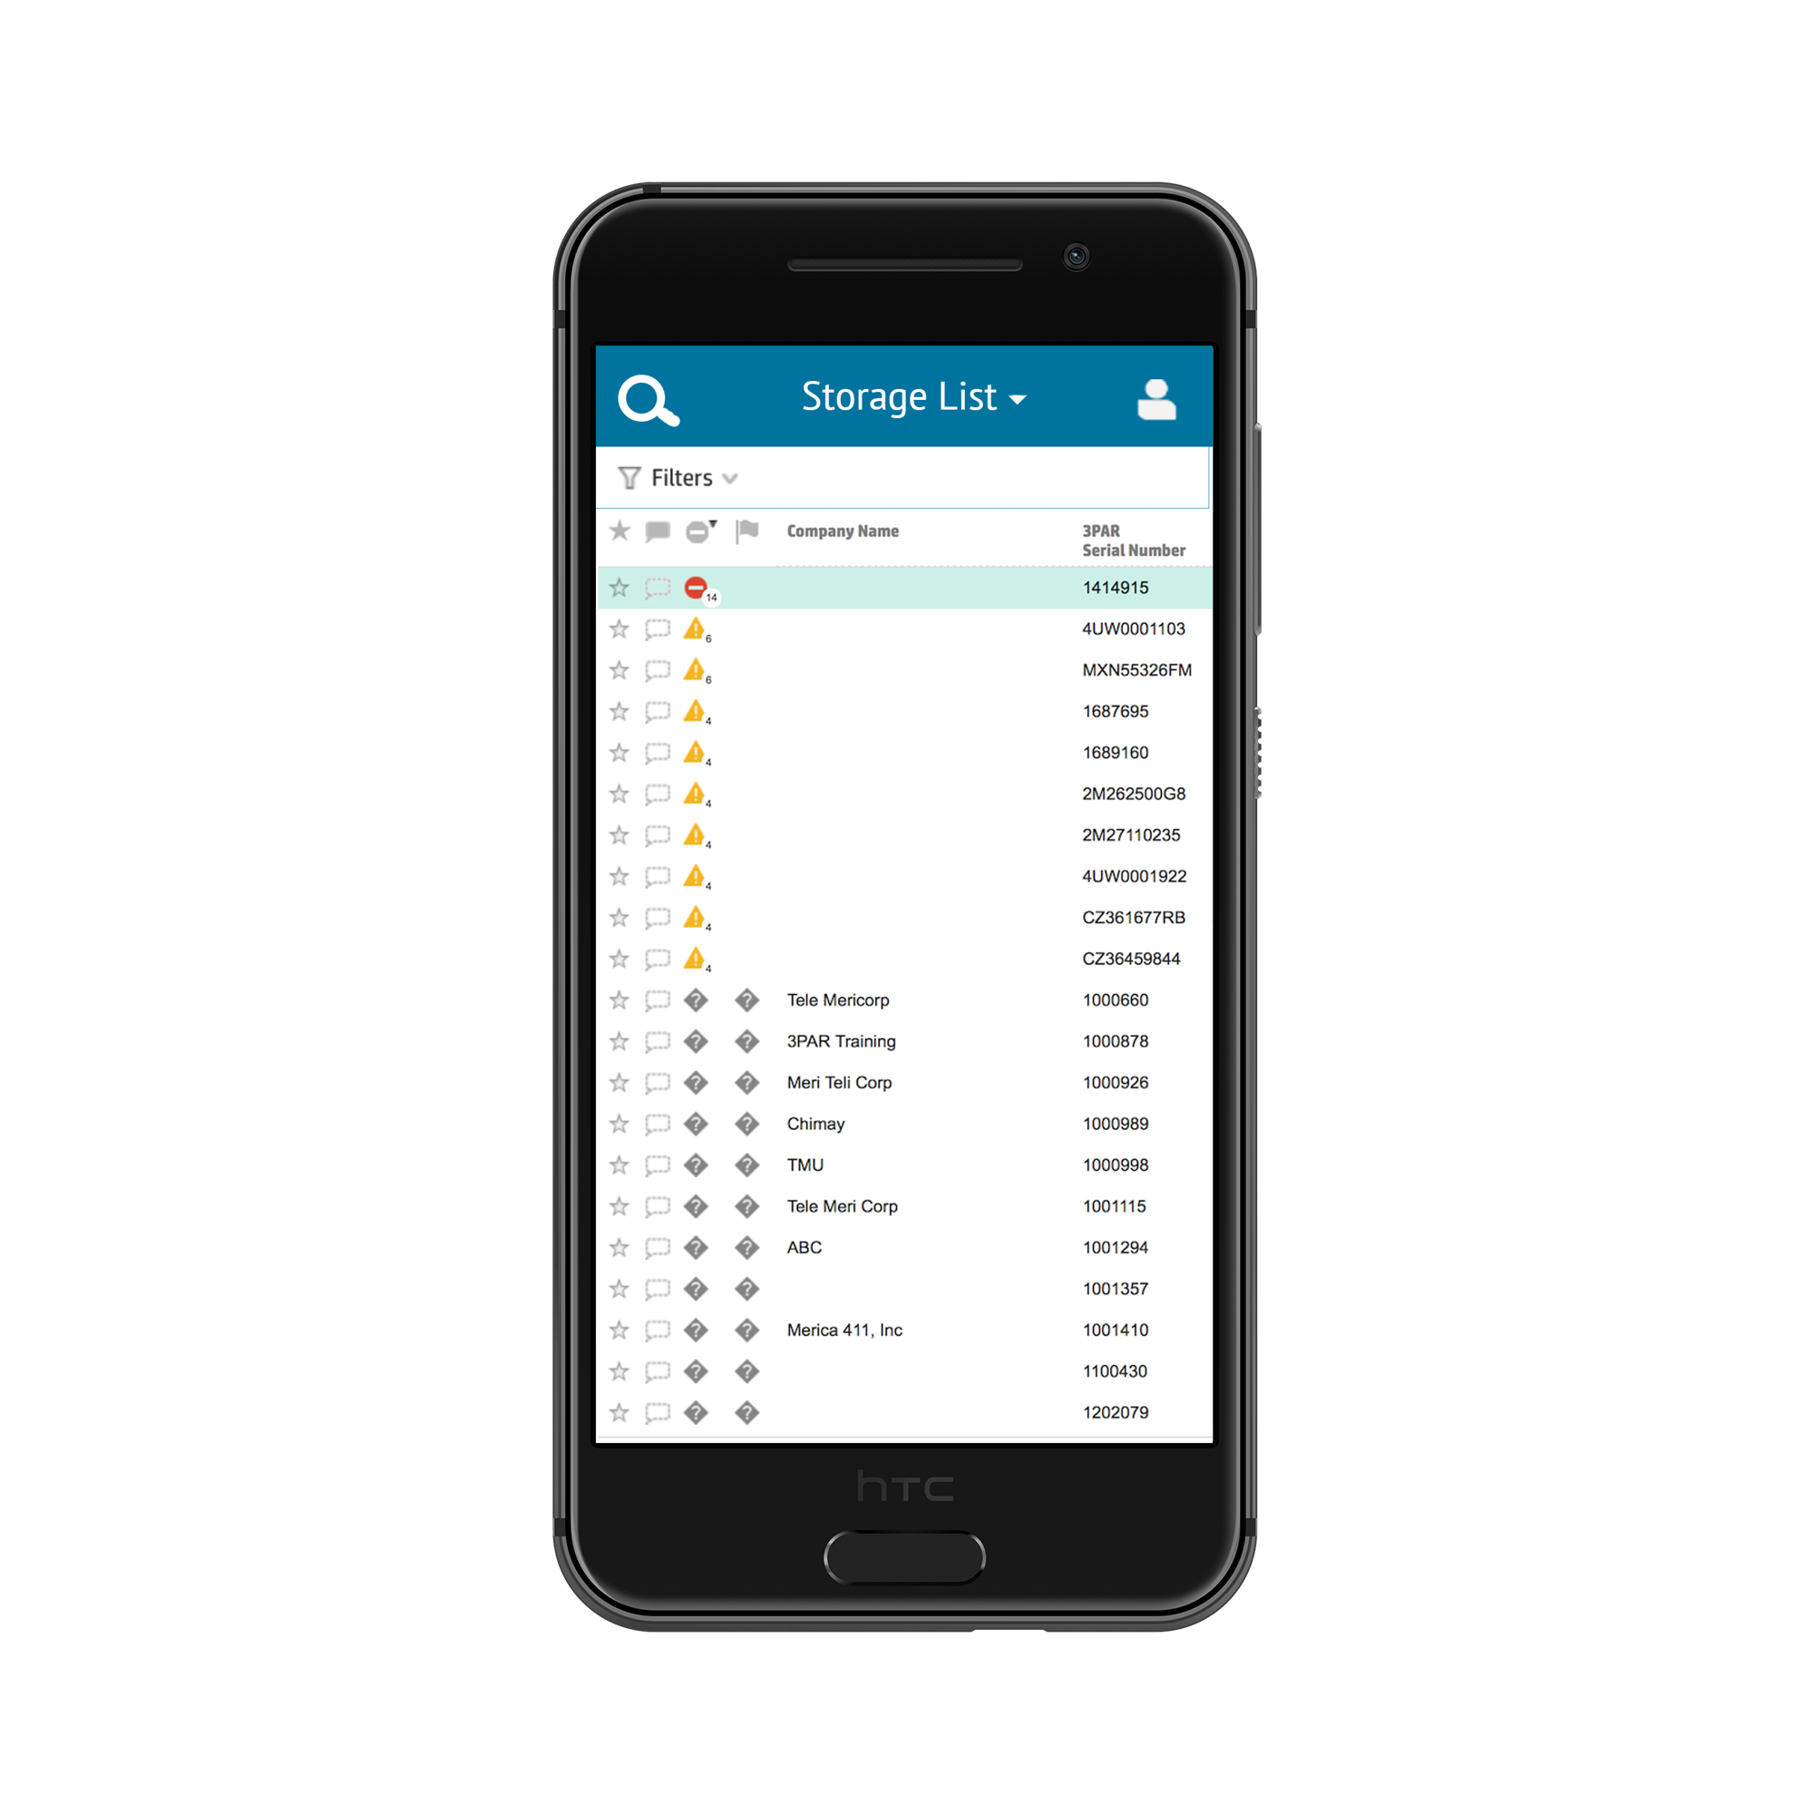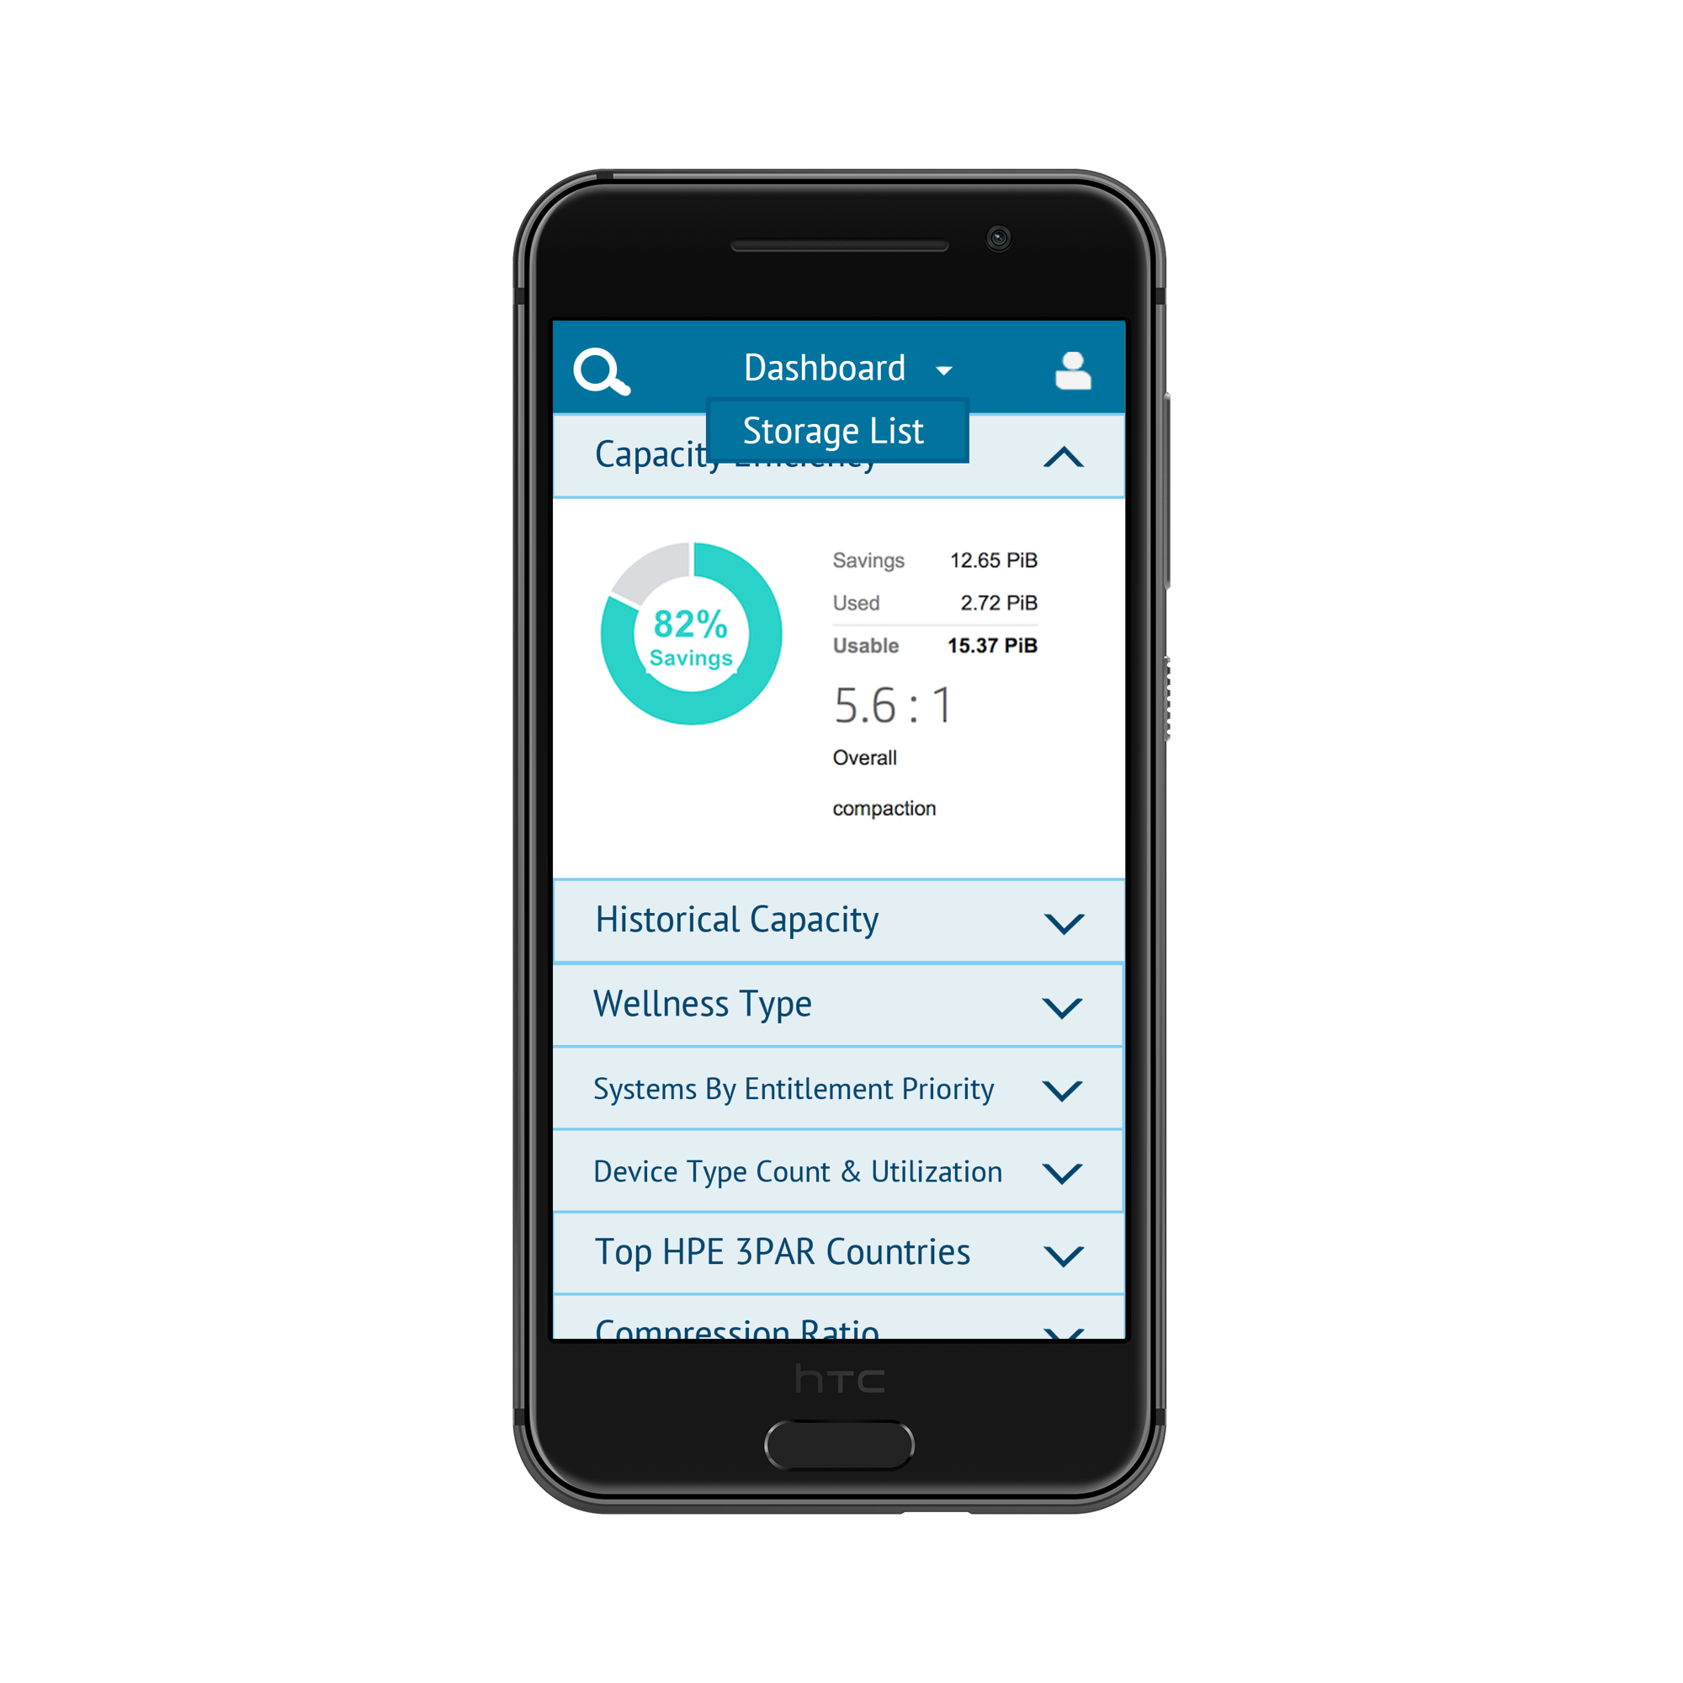



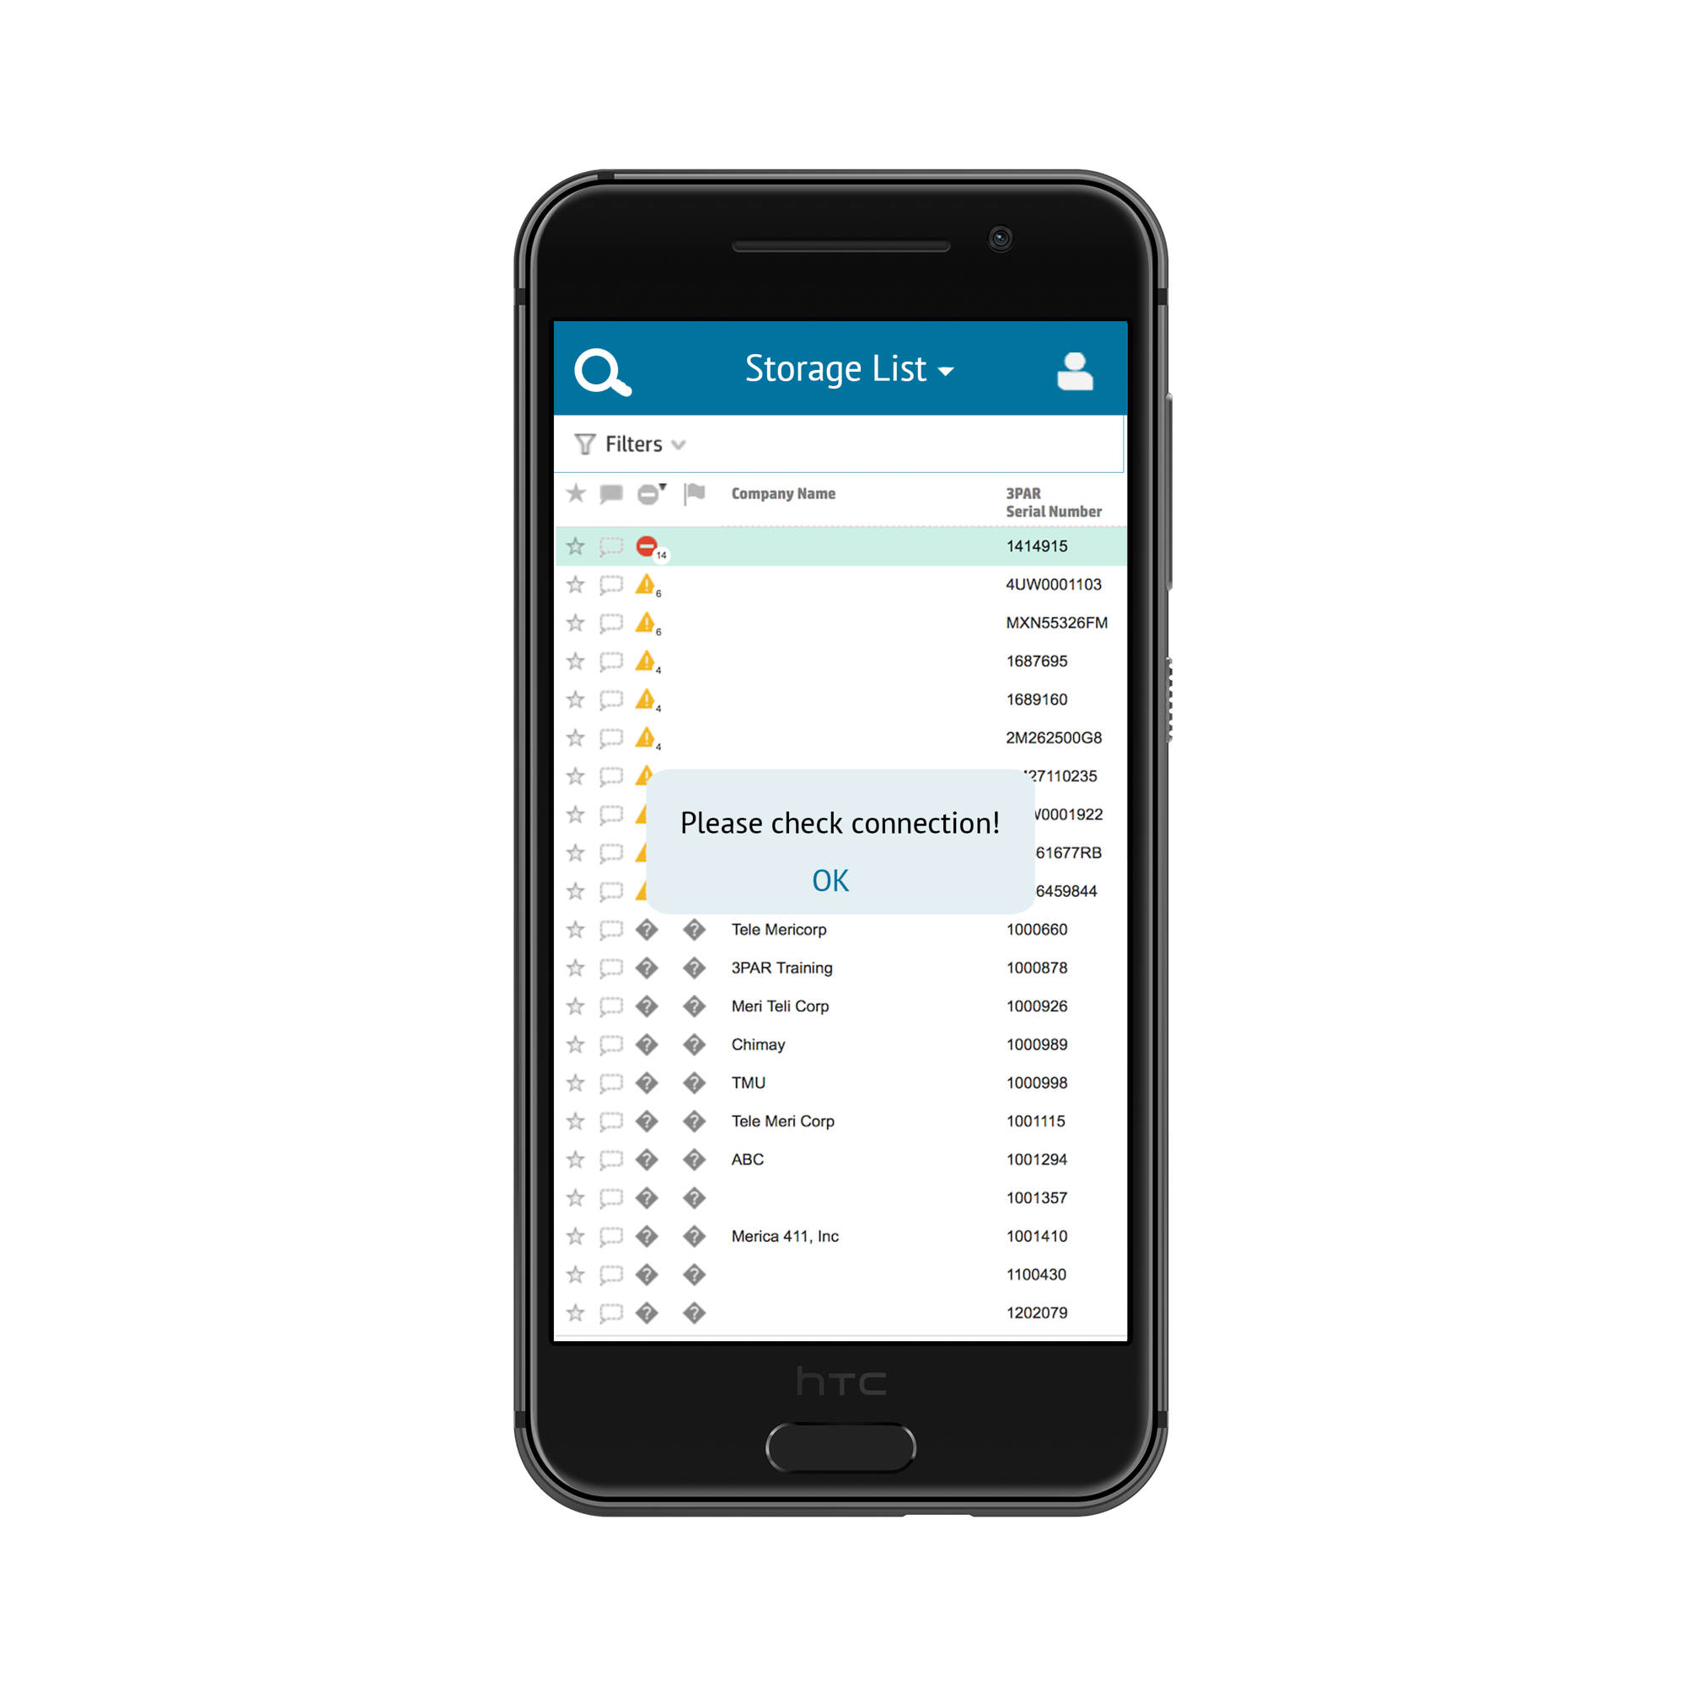

## 6.3 Use Case 3: User performs search

Tapping on the search button on the upper left corner displays the search bar shown below the navigation bar. Enter keywords to search for a particular storage unit. The screen only displays the search result.

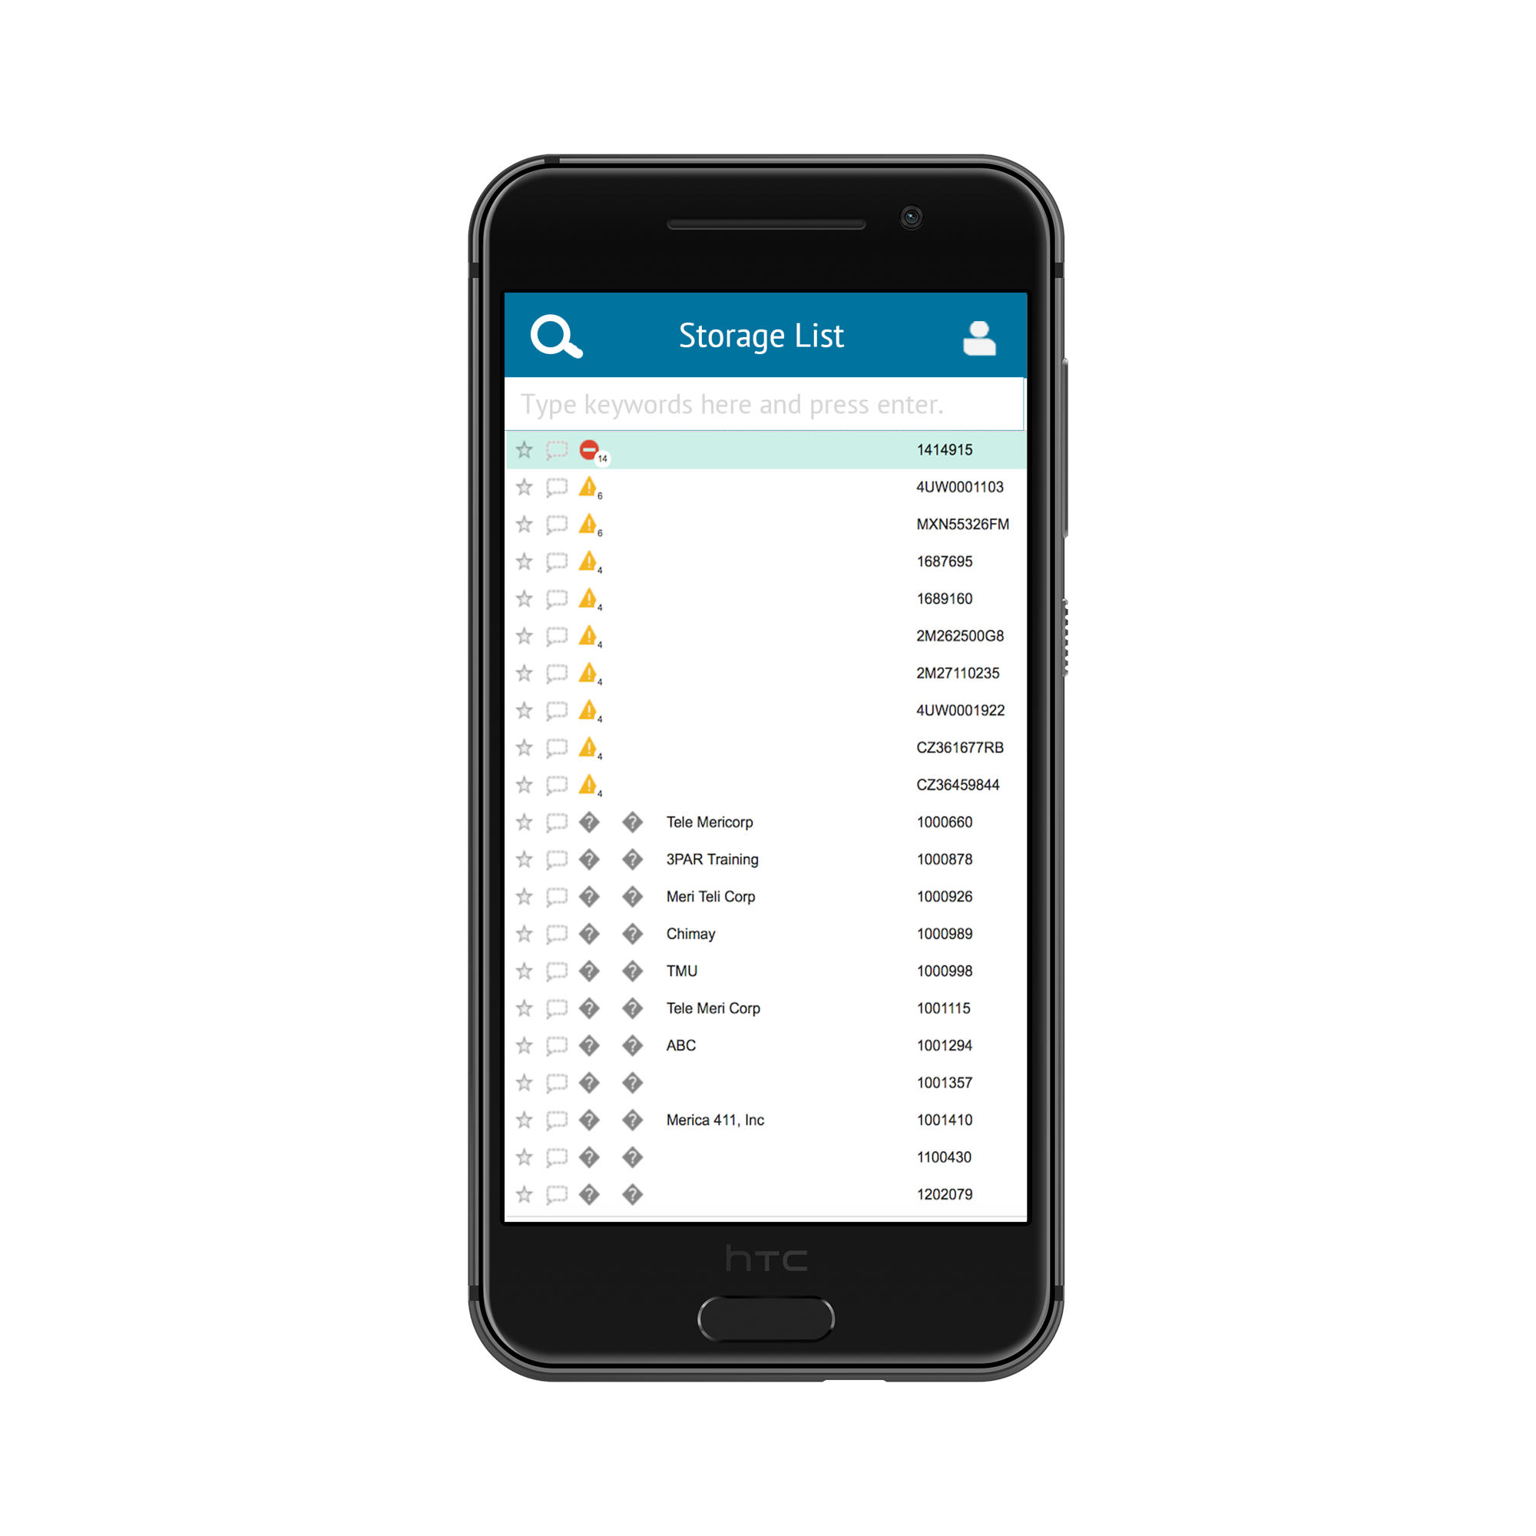

## 

## 

## 

## 

## 

## 

## 6.4 Use Case 4: User selects filter

Tapping the filter below the navigation bar filters the list and the filtered result appears on the screen.

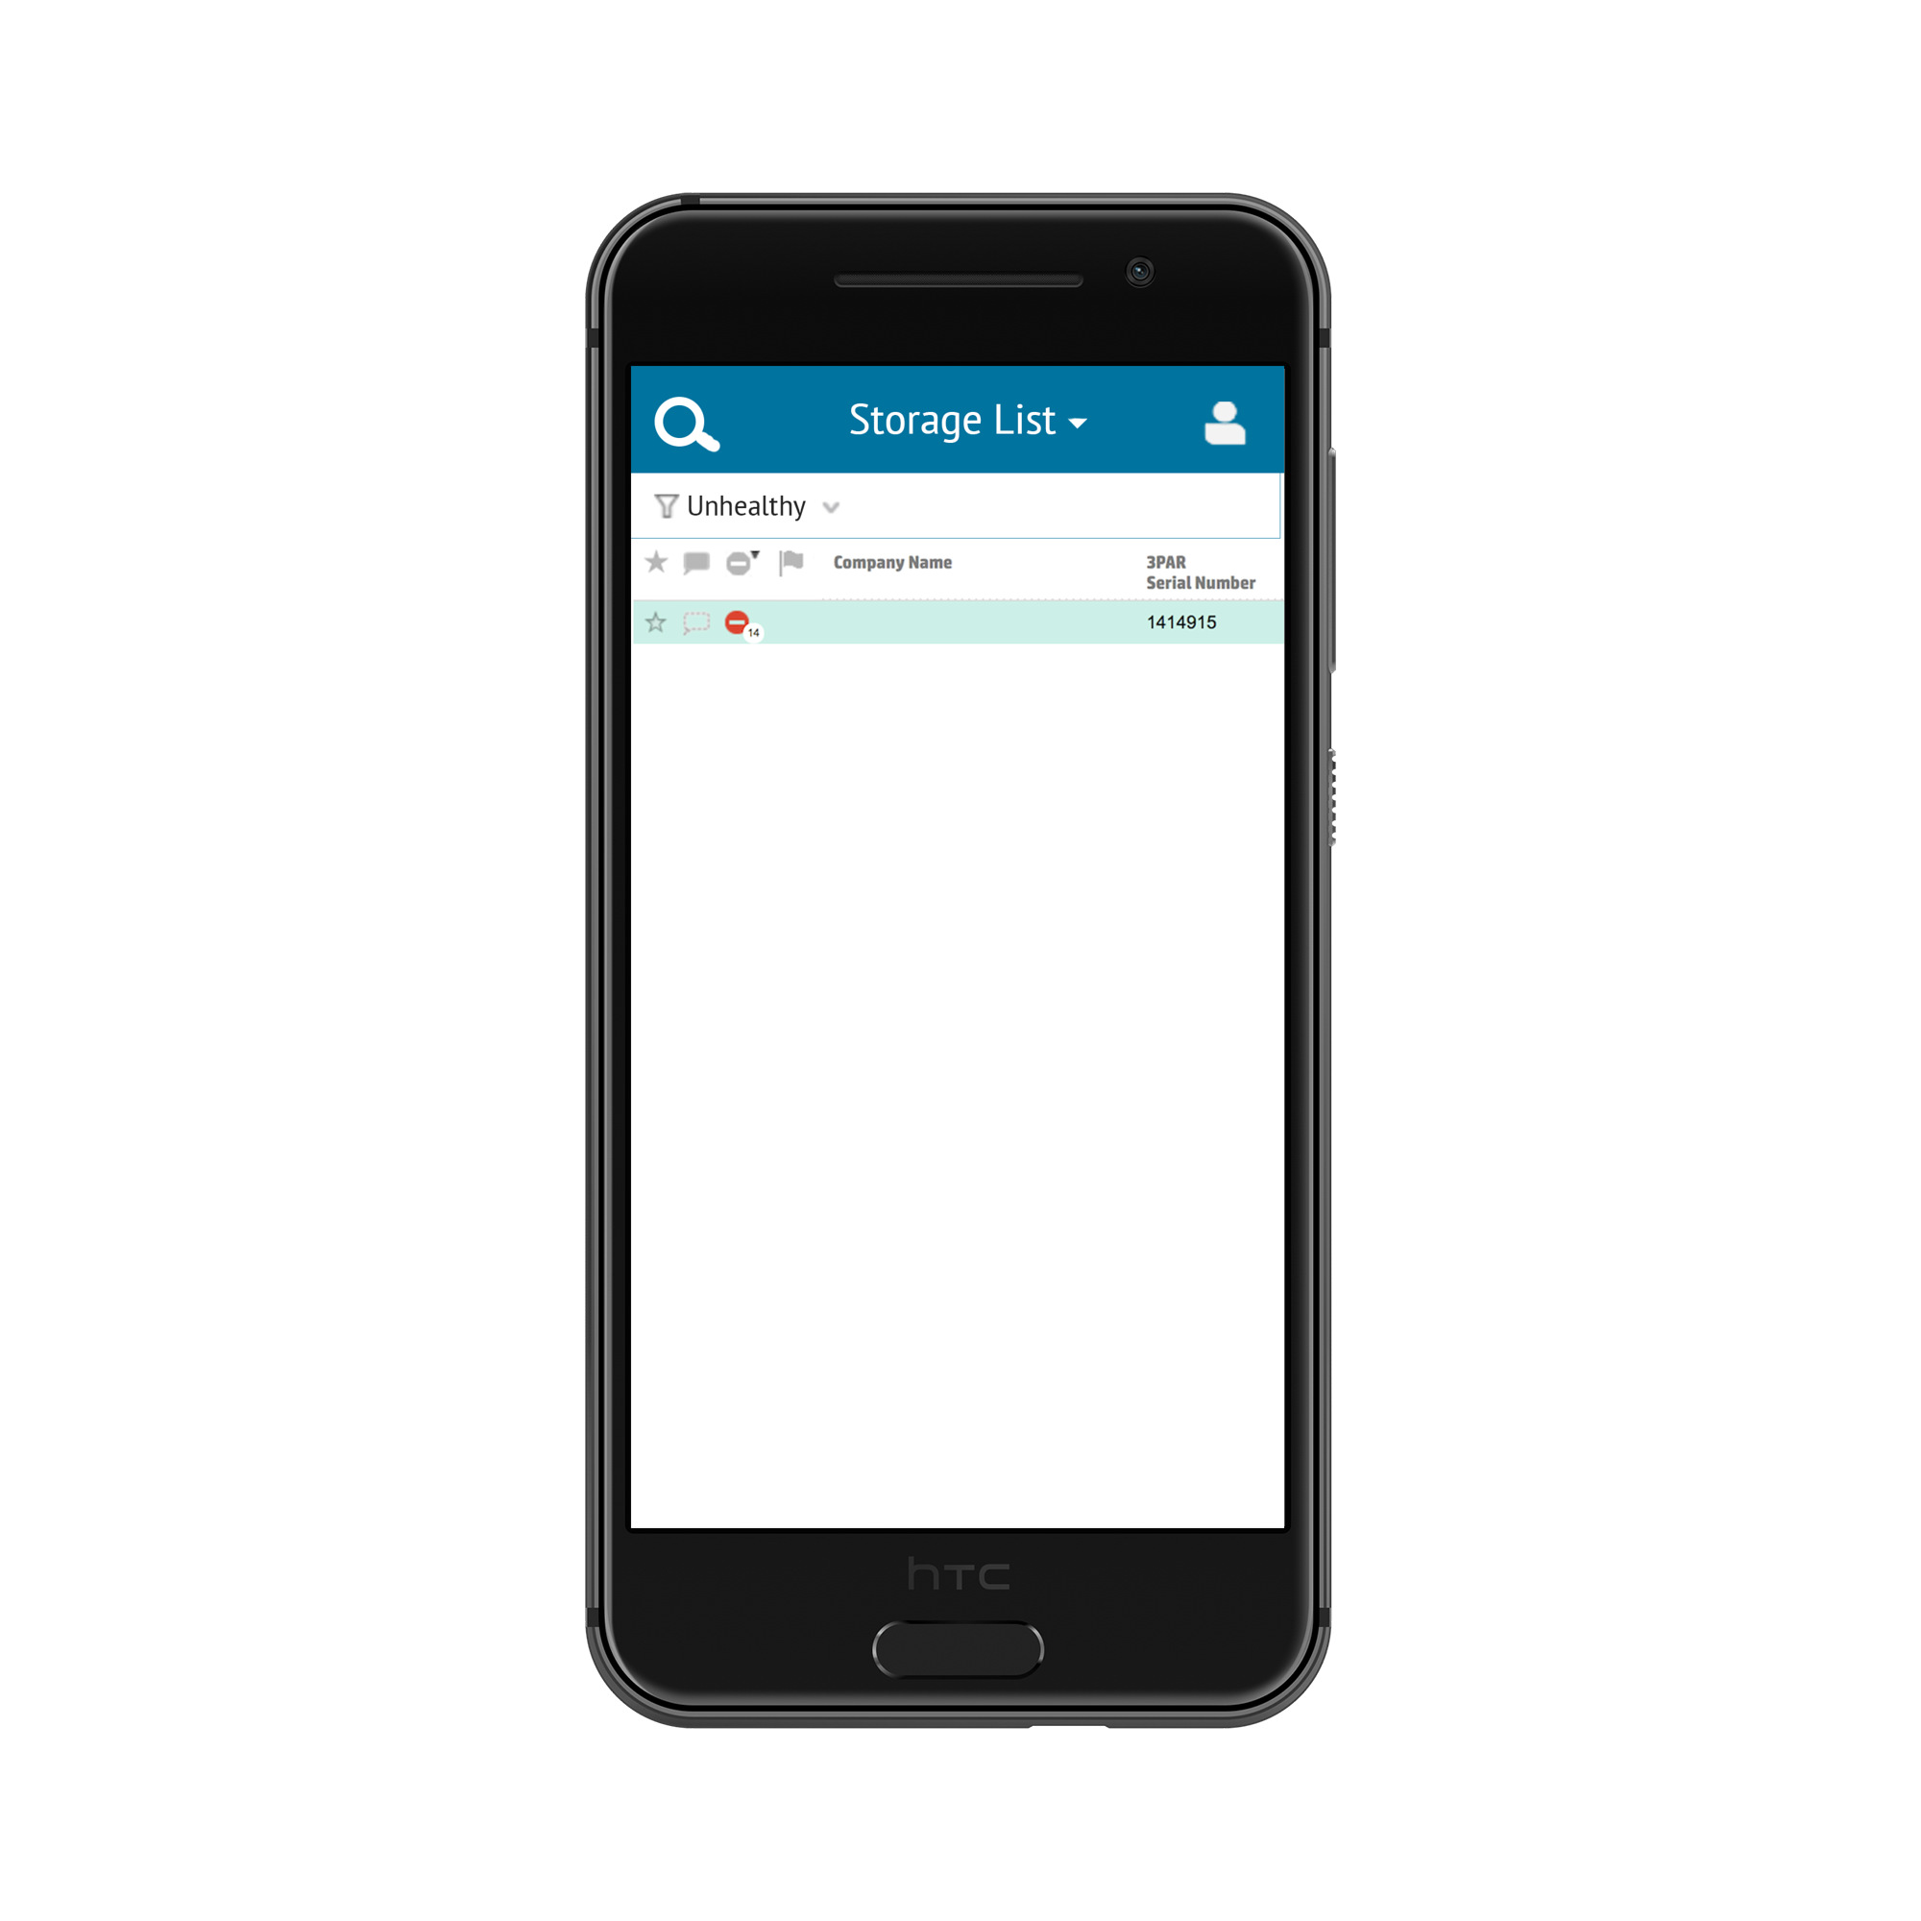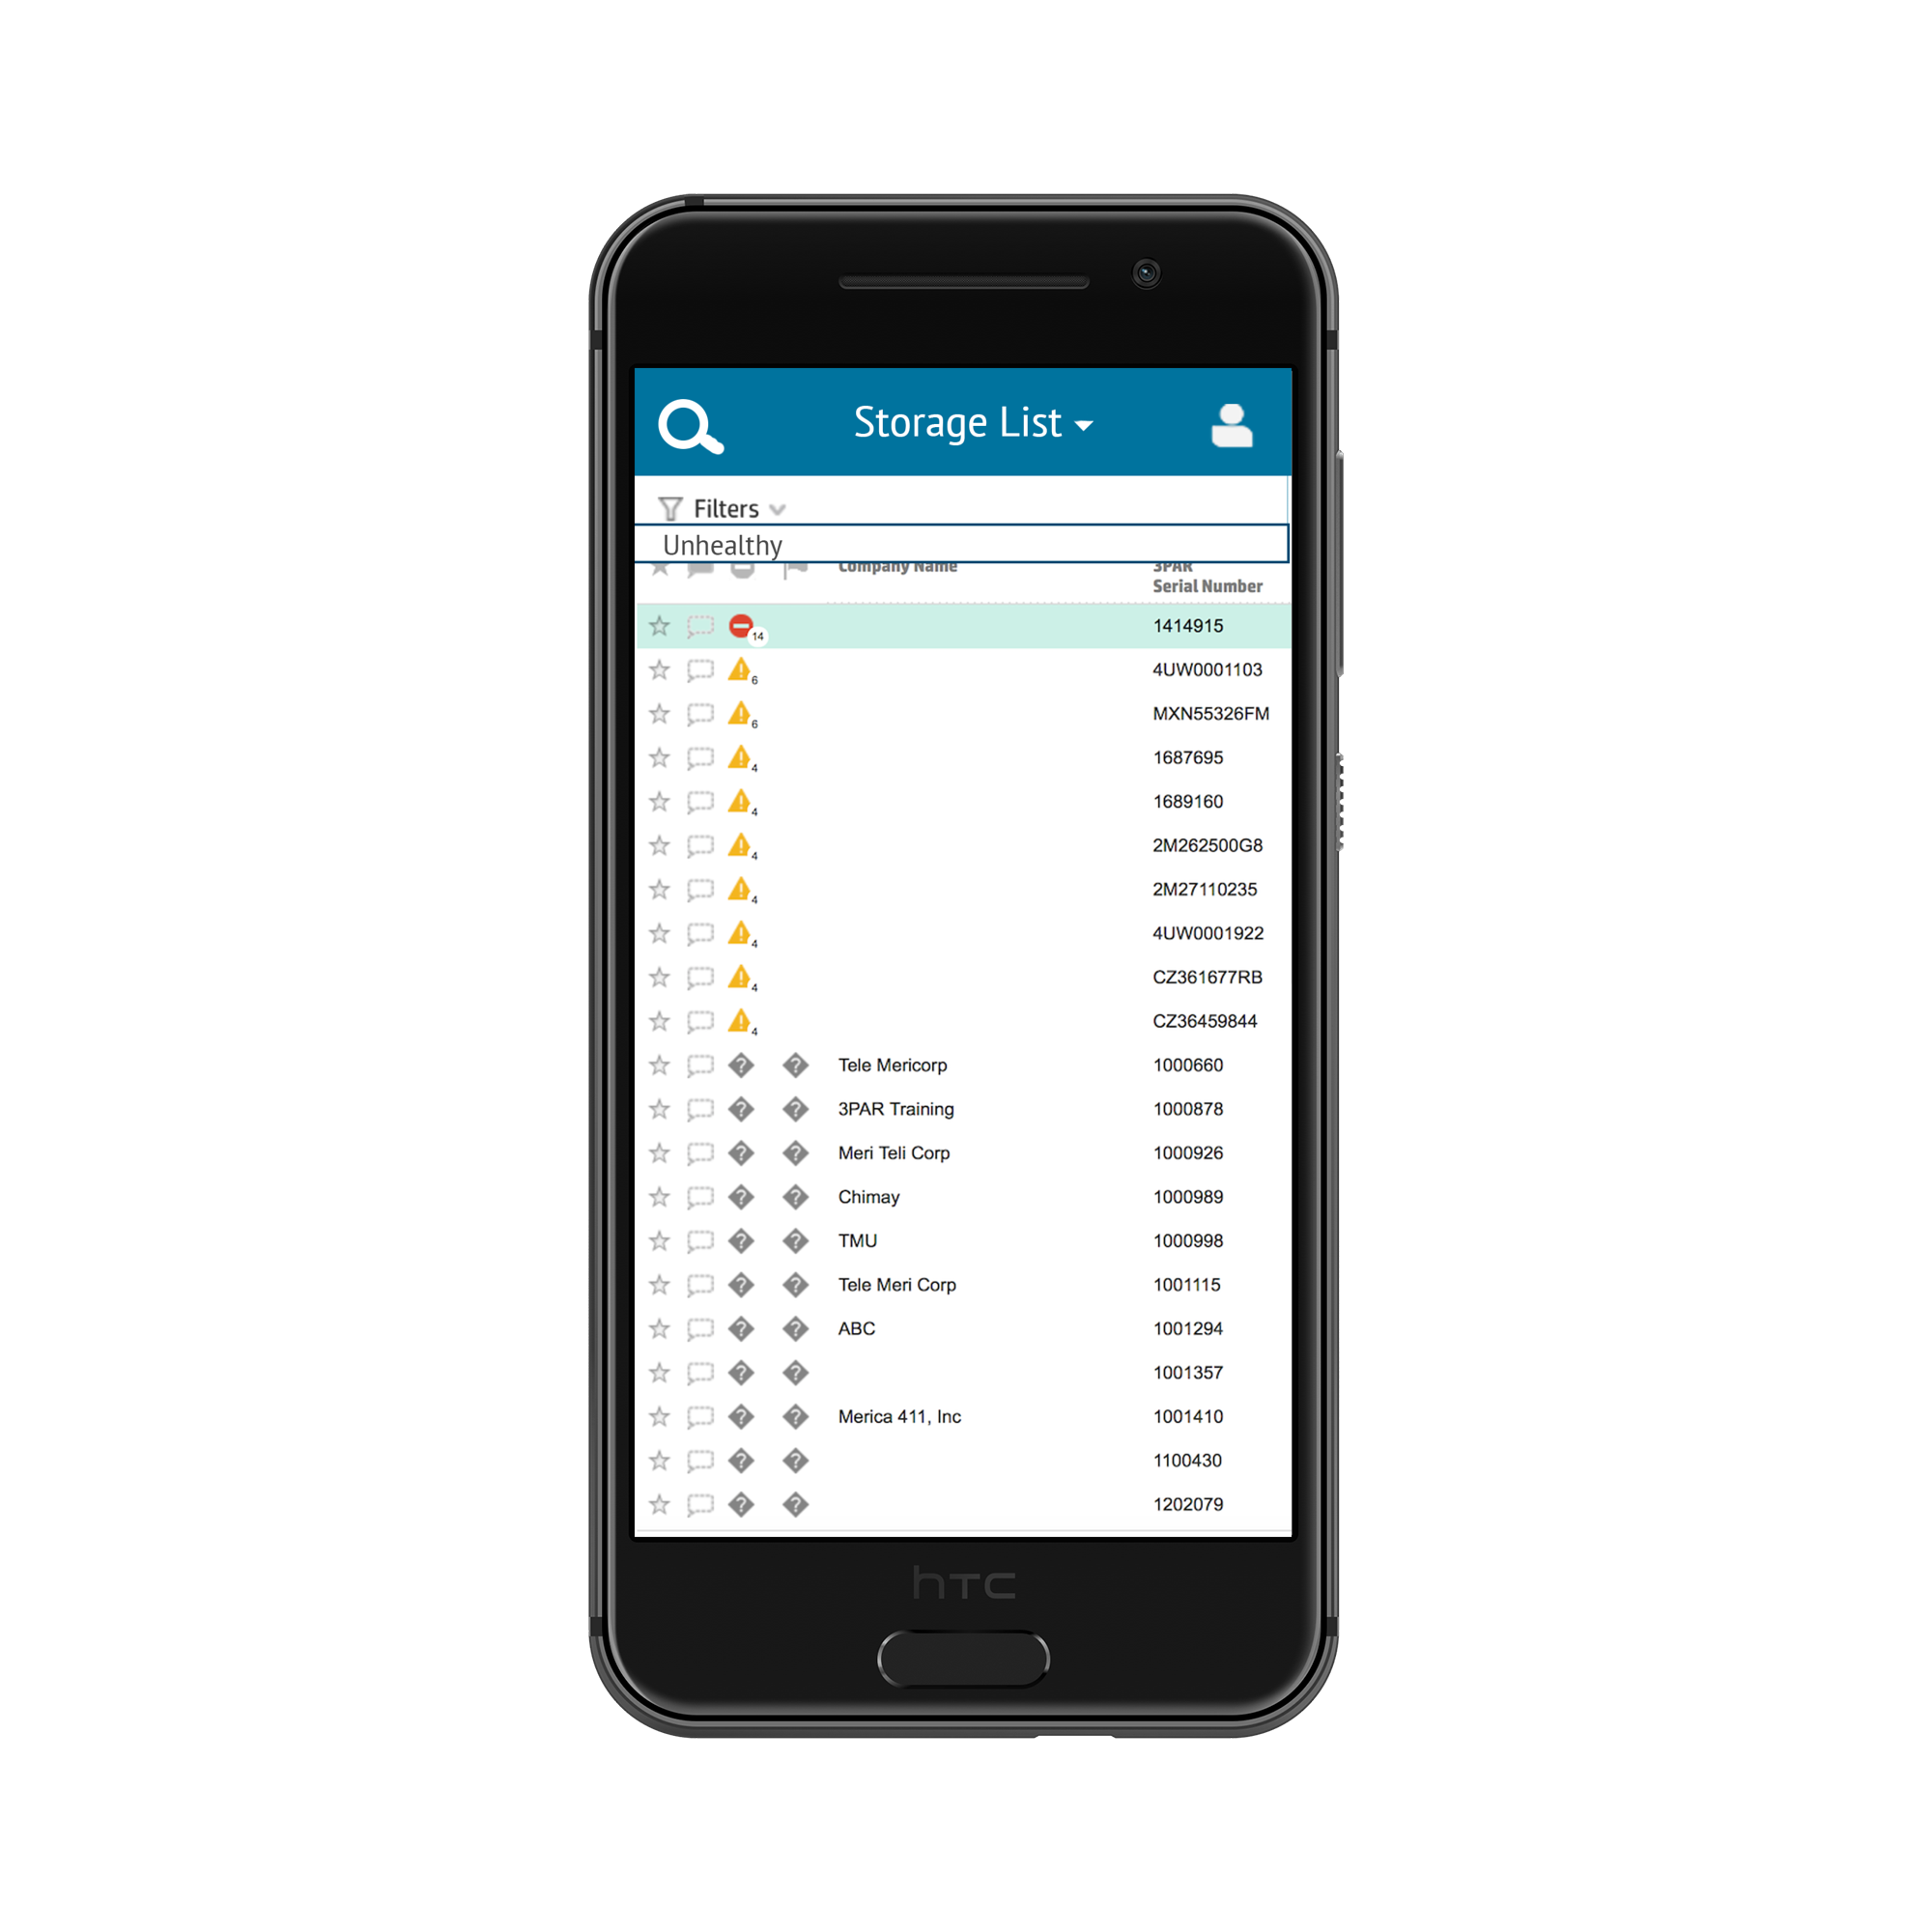





## 6.5 Use Case 5: User goes to dashboard view

After changing to the dashboard view, the graph appears by tapping one of the tabs.

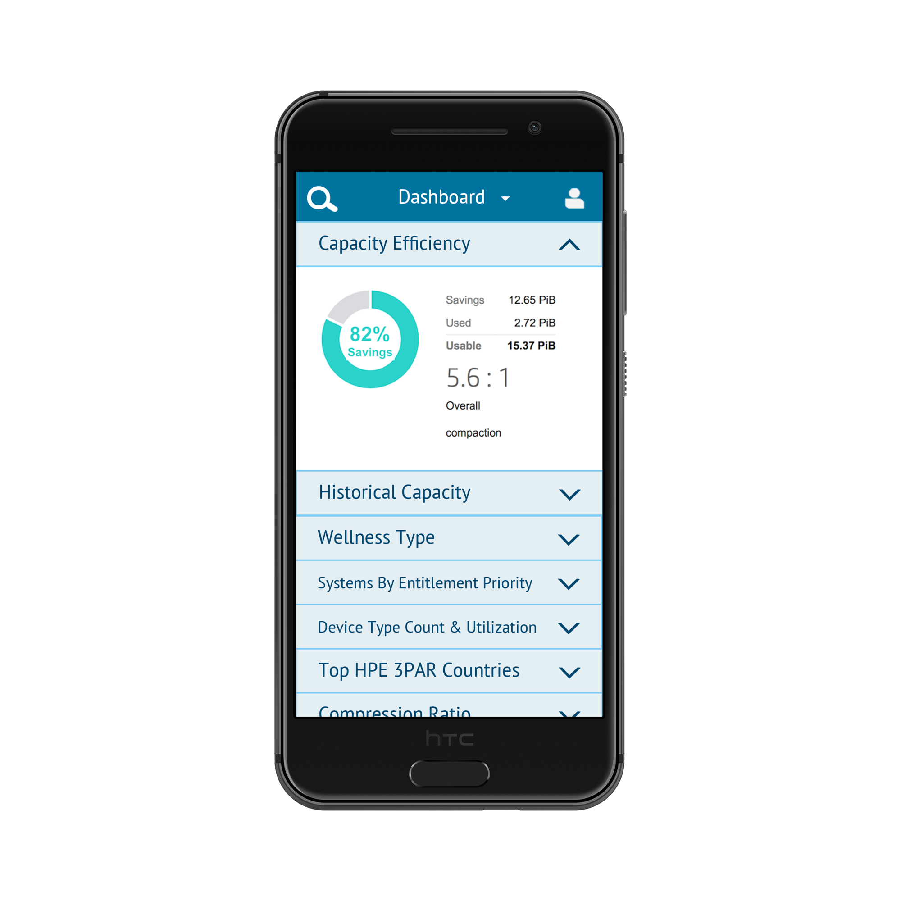





## dashboard-error_htc-onea9-black-portrait.png

## 6.6 Use Case 6: Display disk info

When viewing a list of storage systems, the user can tap on a single system to view a page with more detailed information.

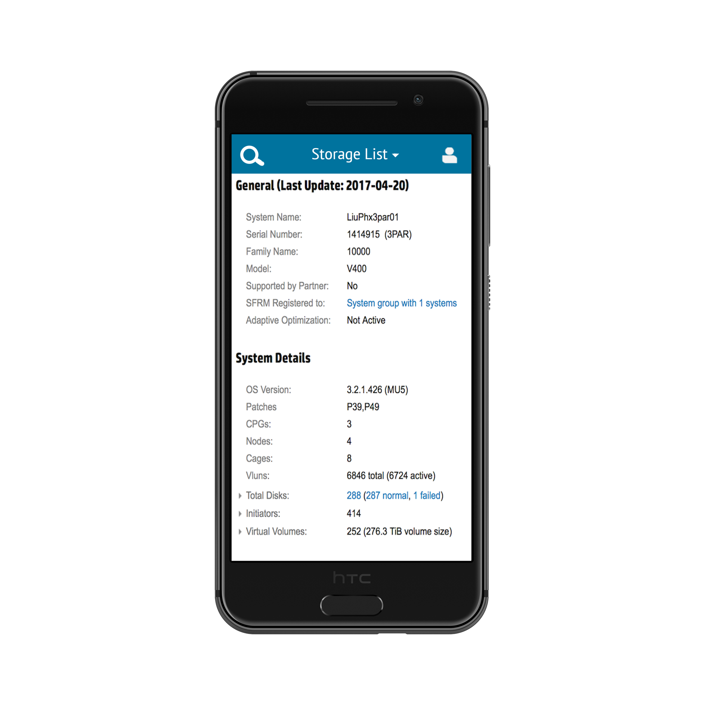

## 

## 

## 

## 

## 

## 

## 6.7 Use Case 7: Send disk health alerts

An enumerated red dot in the upper right corner indicates health alerts. Tapping on the figure displays the right menu. Tapping on the tab with the alert shifts the menu to the left and displays alert details.

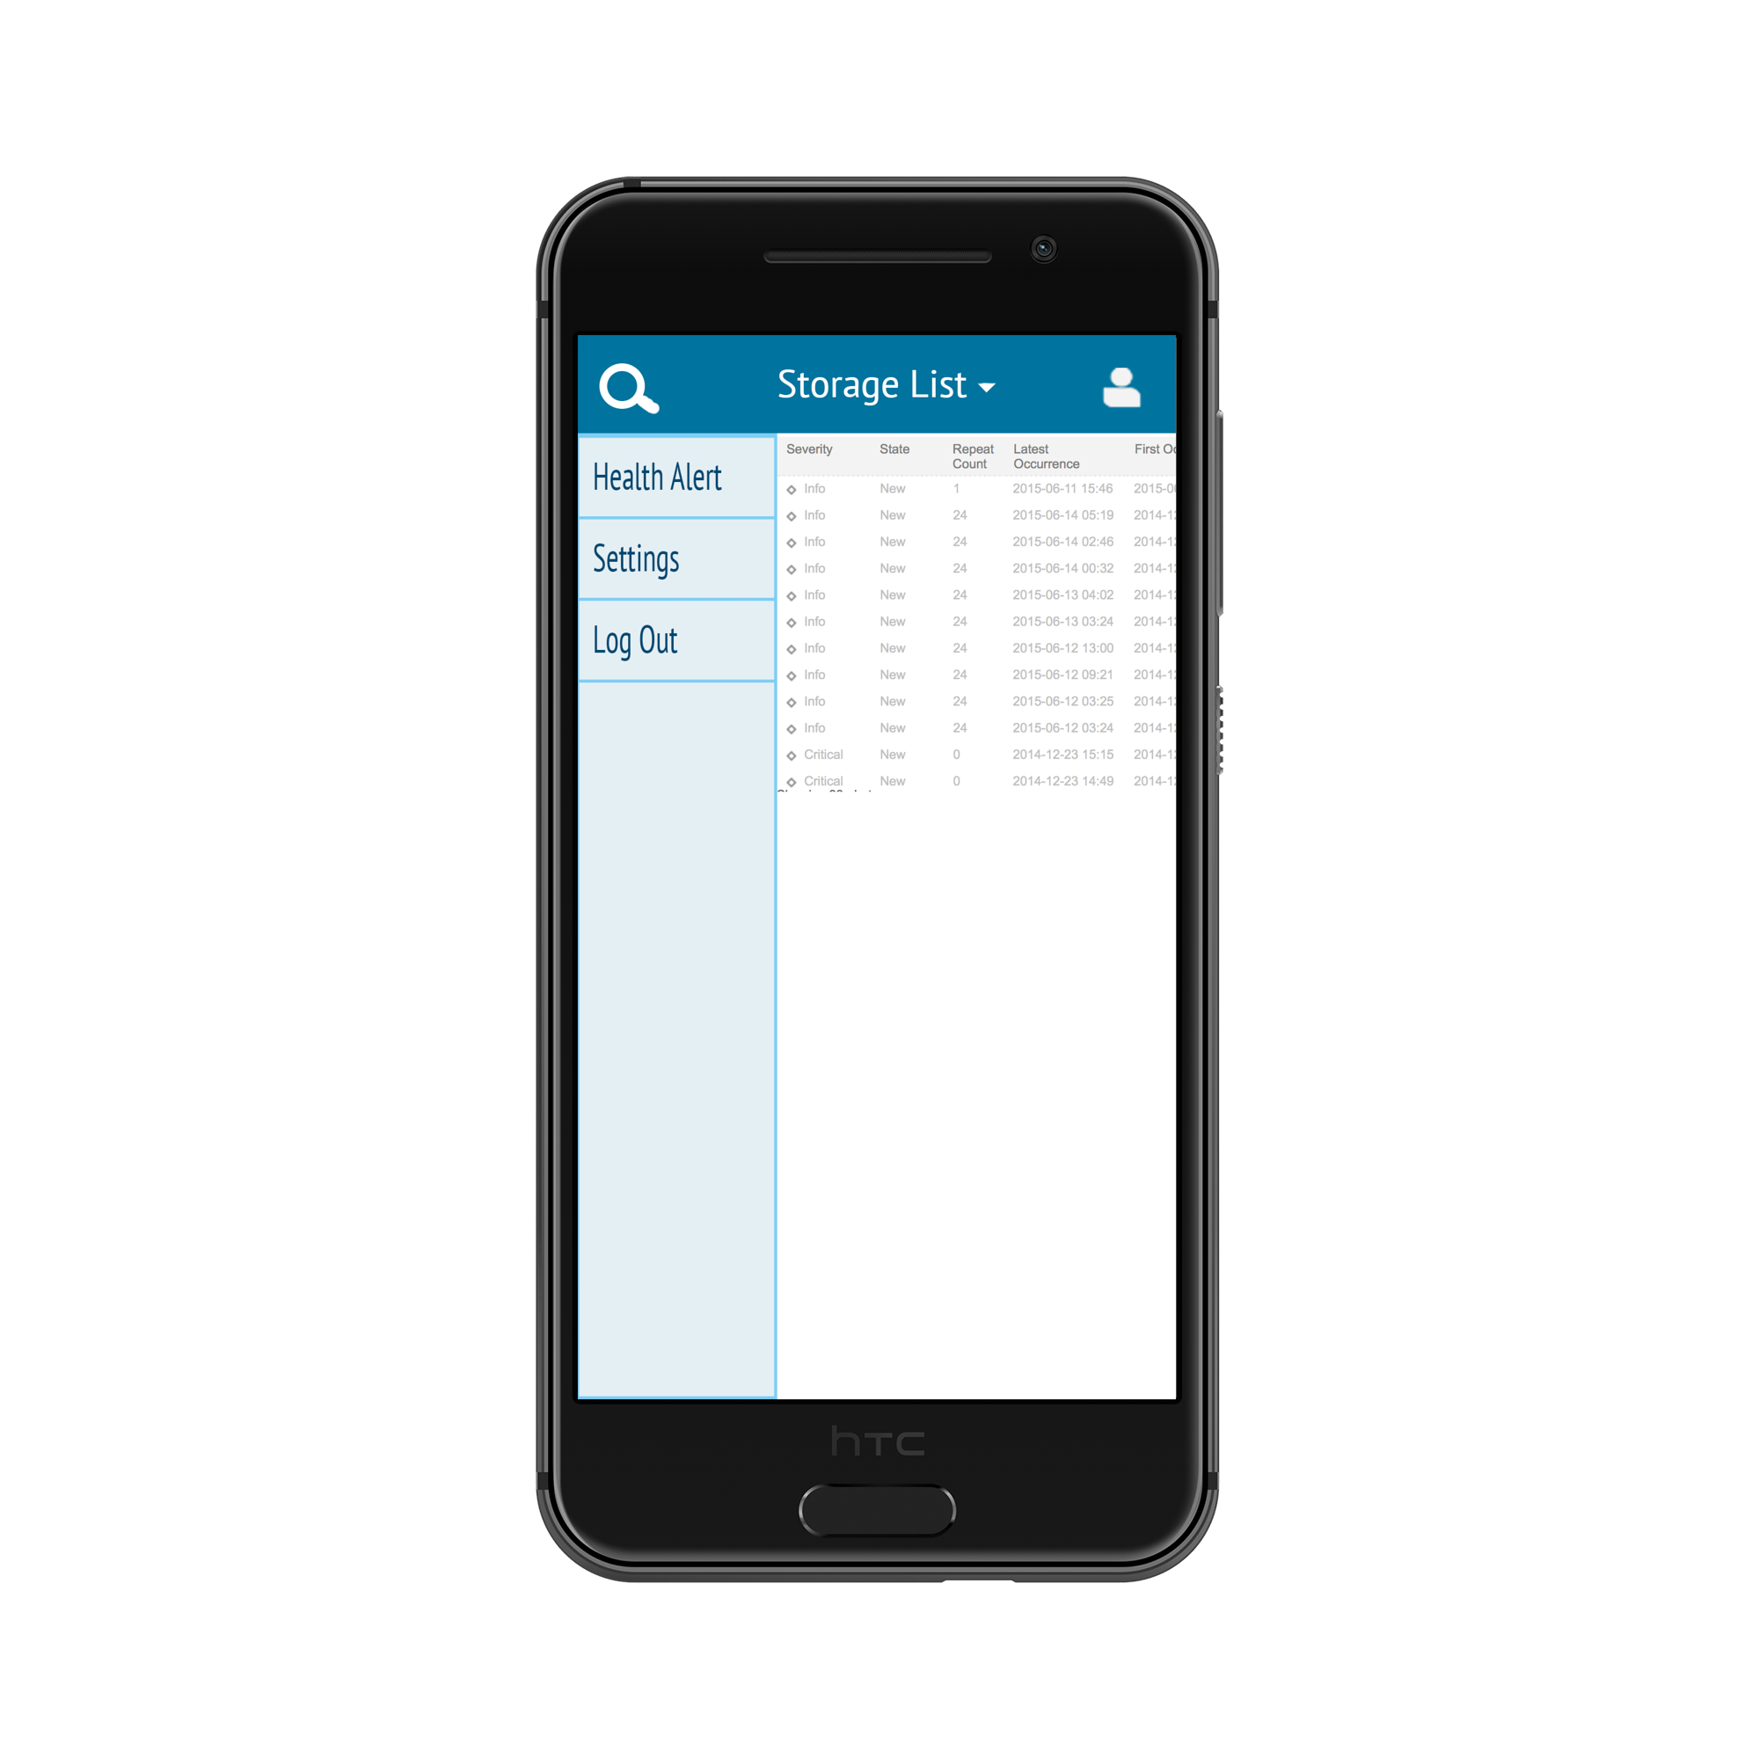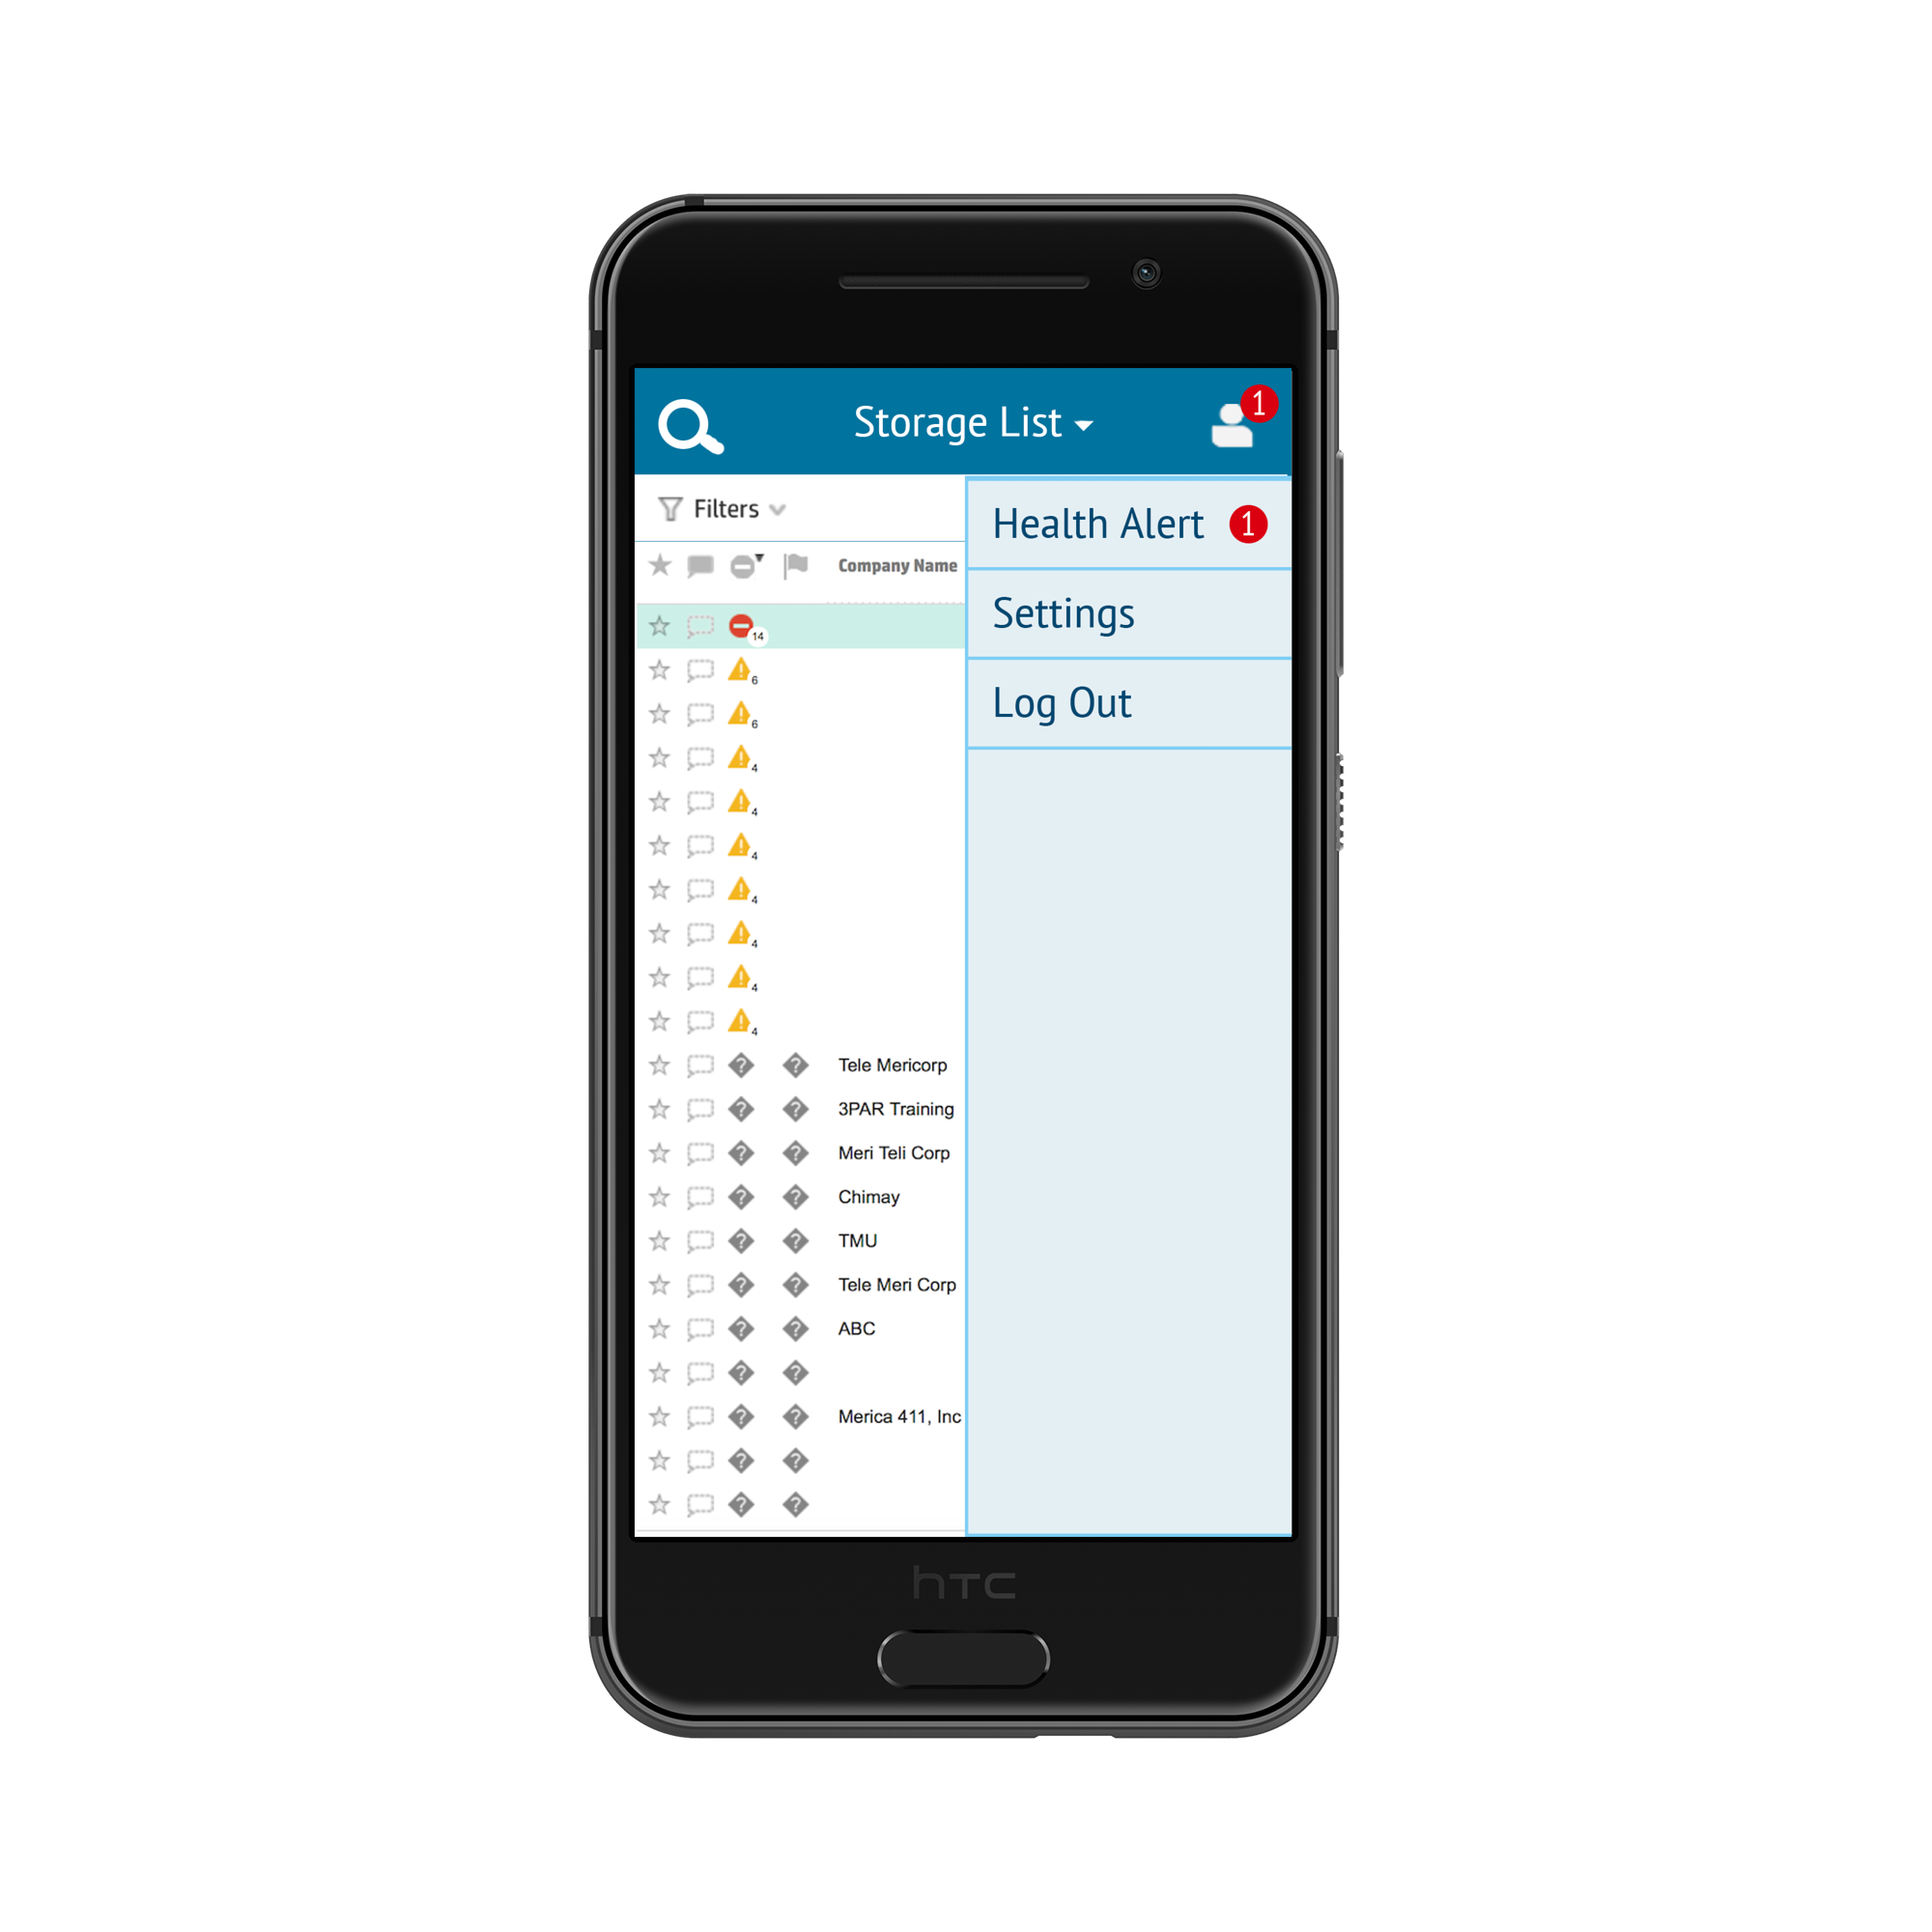

# 

# 

# 7. Glossary of Terms

|  |  |
| --- | --- |
| Term | Definition |
| Admininstrator | Agent responsible for upkeep of mobile application. This includes periodic data updates to ensure accuracy in analytics. |
| Customer | Owner of one or multiple HP storage systems. Should be able to use the app to track their systems’ data and performance. |
| Dashboard | A User Interface that displays disk information in an easy-to-read manner. |
| Data Analytics | Information about data stored in users’ systems such as amount of total space, amount of storage used, type of storage device, etc. |
| Disk Information | Details about a given system including name, capacity, efficiency, etc. |
| Employee | Users working at HP such as administrators, sales, and support. |
| Health Alerts | Notification of when disk information should be reviewed. Indicates something alarming such as low bandwidth or low storage capacity. |
| Sales | Agent interested in sales opportunities. Uses the platform to gather information on customer use to be able to assist in selling them appropriate products (e.g. more storage). |
| Support | Agent interested in detecting and troubleshooting problems. Uses the app to diagnose issues with storage devices or usage. |